
Ministry Of Higher Education
Modern Academy
For Computer Science and
Management Technology
In Maadi



Smart Insole for Foot Ulcer Prediction
Submitted to
Modern Academy Computer Science and Management Technology in Maadi Computer Science Department
Prepared by
Hassan Sherif Hassan Heba Muhamed Aly
Ahmed Farag Khodary Heba Ehab Muhamed
Ahmed Samy El Sayed
Supervised by
Dr: Lamiaa Hassaan
Eng: Tarek El Gamal

Academic Year: 2025/2026

Team Members

Name | ID | Description
Heba Muhamed Aly | 12300023 | AI
Hassan Sherif Hassan | 12300065 | AI
Ahmed Farag Khodary | 12300269 | Flutter Developer
Ahmed Samy El Sayed | 12300275 | Embedded System
Heba Ehab Muhamed | 12300607 | Backend Developer

Acknowledgement
We would like to express our sincere appreciation to everyone who supported and guided us throughout the development of this project. Working on the Smart Insole for Foot Ulcer Prediction system has provided us with valuable practical experience in Intelligent Healthcare Technology.
This project enhanced our technical, analytical, and problem-solving skills while allowing us to contribute to a real-world healthcare solution aimed at supporting preventive healthcare and early disease prediction.
We also extend our deepest gratitude to Modern Academy for providing us with the opportunity and environment to complete this project successfully.
Special thanks to Dr Lamiaa Hassaan and Eng Tarek El Gamal for their continuous support, valuable guidance, and encouragement throughout the project duration.
We would also like to thank the Department of Computer Science staff, especially Prof. Dr. Mahmoud Gad-Allah, for his supervision, insightful advice, and continuous motivation that greatly contributed to the successful completion of this work.

Abstract
This project presents the development of an intelligent healthcare system that integrates Artificial Intelligence, Embedded Systems, and Mobile Application technologies to support early disease prediction and patient monitoring. The core of the system is a Smart Insole designed to measure foot pressure and temperature in real time, enabling early detection of conditions associated with diabetic foot ulcers using machine learning models.
In addition to ulcer prediction, the system includes multiple AI-powered modules such as diabetic foot ulcer image classification with severity grading, stroke risk prediction based on patient input data, and a general health assessment module capable of predicting multiple healthcare conditions.
The proposed platform also provides several supporting features, including personalized nutrition planning, medical report analysis, future health condition simulation, result explanation, and an AI-based chatbot assistant to enhance user interaction and understanding.
By combining hardware sensing, artificial intelligence, and mobile healthcare technologies, the proposed system provides a comprehensive and scalable healthcare solution aimed at improving early diagnosis, preventive healthcare, and patient quality of life.

Chapter 1 .............................................................................................................. 10
- Introduction and Background ........................................................................................ 11
1.1 Introduction ............................................................................................................. 11
1.1.1 Background of the Problem ............................................................................. 12
1.1.2 Motivation ........................................................................................................ 13
1.1.3 Objectives of the Project .................................................................................. 14
1.2 Literature Review / Related Work ........................................................................... 17
1.2.1 Historical Overview of Smart Healthcare Systems .......................................... 19
1.2.2 Comparison between Traditional and AI-Based Healthcare Systems ...............20
1.3 System Overview ..................................................................................................... 22
1.3.1 General Architecture of the Proposed System .................................................. 22
1.3.2 Description of Main Modules and Interactions ................................................. 24

Chapter 2 .............................................................................................................. 25
2. System Analysis and Design .................................................................................................. 26
2.1 Smart Insole Data Processing ........................................................................................... 27
2.1.1 Pressure and Temperature Sensing Mechanism ......................................................... 30
2.1.2 Data Preprocessing and Feature Extraction ................................................................ 33
2.1.3 AI-Based Ulcer Risk Prediction Logic ....................................................................... 34
2.2 Diabetic Foot Ulcer Image Classification .......................................................................... 36
2.2.1 Image Input and Preprocessing ................................................................................... 38
2.2.2 Severity Grading (Grade 1–4 Classification) .............................................................. 41
2.2.3 Model Output Interpretation ........................................................................................ 45
2.3 Stroke Prediction System .................................................................................................... 47
2.3.1 Input Feature Selection .................................................................................................. 48
2.3.2 AI Prediction Model ...................................................................................................... 50
2.3.3 Result Interpretation ...................................................................................................... 51
2.4 General Health Prediction System........................................................................................ 53
2.4.1 Health Data Collection and Feature Processing.................................................................................. 54
2.4.2 Machine Learning Prediction Model ............................................................................. 55
2.4.3 Result Interpretation and Healthcare Recommendation................................................. 57

Chapter 3 .............................................................................................................. 59
3. Proposed Intelligent Healthcare System ................................................................................. 60
3.1 System Modules Overview ................................................................................................ 61
3.1.1 Smart Insole Module .................................................................................................... 61
3.1.2 Mobile Application (Flutter) ........................................................................................ 63
3.1.3 Backend System ........................................................................................................... 64
3.1.4 AI Services Integration ................................................................................................ 65
3.2 System Architecture ....................................................................................................... 67
3.2.1 System Flow Diagram .............................................................................................. 67
3.2.2 Data Flow Diagram (DFD) ....................................................................................... 69
3.2.3 Use Case Diagram ..................................................................................................... 70

Chapter 4 .............................................................................................................. 72
4. Implementation ..................................................................................................................... 73
4.1 AI Model Implementation ................................................................................................ 73
4.1.1 Ulcer Prediction Model ................................................................................................ 75
4.1.2 Stroke Prediction Model .............................................................................................. 77
4.1.3 General Disease Prediction Model ............................................................................... 78

4.2 Mobile Application Implementation .................................................................................. 80
4.2.1 Core Structure and Navigation ..................................................................................... 81
4.2.2 User Authentication ...................................................................................................... 82
4.2.3 Health Dashboard ......................................................................................................... 83
4.2.4 Nutrition Planner Module ............................................................................................. 84
4.2.5 Chatbot Integration ....................................................................................................... 85
4.2.6 Medical Report Upload & Analysis ............................................................................. 86
4.2.7 Future Scenario Simulation .......................................................................................... 87
4.2.8 AI Result Explanation System....................................................................................... 88
4.3 Backend and Cloud Integration ........................................................................................... 89
4.3.1 Backend Architecture .................................................................................................... 90
4.3.2 Database Design ............................................................................................................ 91
4.3.3 API Communication ...................................................................................................... 91

Chapter 5 .............................................................................................................. 93
5. Testing and Evaluation .......................................................................................................... 94
5.1 Testing Scenarios ............................................................................................................... 94
5.1.1 Smart Insole Data Testing ............................................................................................. 95
5.1.2 Ulcer Prediction Testing ............................................................................................... 96
5.1.3 Stroke Prediction Testing .............................................................................................. 97
5.1.4 General Health Prediction Testing ................................................................................ 98
5.2 Performance Metrics .......................................................................................................... 98
5.2.1 Accuracy and Model Evaluation ................................................................................... 99
5.2.2 System Response Time ................................................................................................. 102
5.3 Discussion .......................................................................................................................... 102
5.3.1 Results Analysis ............................................................................................................ 103
5.3.2 Limitations ................................................................................................................... 103
5.3.3 Lessons Learned .......................................................................................................... 104

Chapter 6 .............................................................................................................. 106
6. Conclusion and Future Work ................................................................................................. 107
6.1 Conclusion ........................................................................................................................ 107
6.2 Future Enhancements ....................................................................................................... 110
6.2.1 AI Model Improvement .............................................................................................. 110
6.2.2 Smart Healthcare Expansion ...................................................................................... 111
6.2.3 Integration with Wearable Devices ............................................................................ 112

References ........................................................................................................... 113

Appendices........................................................................................................... 116

Appendix A — AI Model Code…………..............................................................................116

Appendix B — Embedded Sensor Code………….................................................................118

Appendix C — Flutter Application Code…………………………………………………….119

Appendix D — Backend APIs………………………………………………………………..120

List of Figures
Figure 1 .Conceptual illustration of diabetic foot ulcer formation resulting from prolonged abnormal pressure and temperature changes. 12
Figure 2 .Evolution of Smart Healthcare Systems and AI-Based Medical Technologies. 19
Figure 3 .Overall architecture of the proposed intelligent healthcare platform. 23
Figure 4 .Smart Insole Embedded System Architecture 28
Figure 5 .FSR Pressure Sensor Used in Smart Insole. 30
Figure 6 .SHT31 Temperature Sensor 31
Figure 7 .ESP32 Microcontroller for Data Transmission 32
Figure 8 .Medical Image Preprocessing Pipeline for Diabetic Foot Ulcer Classification 40
Figure 9 .DFU Severity Grading Illustration. 42
Figure 10 .MobileNetV2 Architecture for DFU Classification. 44
Figure 11 .Smart Insole Embedded System Architecture. 62
Figure 12 .Backend Infrastructure and AI Services Integration within the Proposed Intelligent Healthcare Platform. 65
Figure 13 .System Flowchart of the Proposed Intelligent Healthcare System. 68
Figure 14 .Data Flow Diagram (DFD) of the Proposed Intelligent Healthcare System. 69
Figure 15 .Use Case Diagram of the Proposed Intelligent Healthcare System. 71
Figure 16 .AI Models Workflow and Prediction Pipeline of the Proposed Healthcare Platform. 75
Figure 17 .Diabetic Foot Ulcer Image Classification and Severity Prediction Interface. 76
Figure 18 .Stroke Risk Prediction Result Interface with Healthcare Recommendations. 77
Figure 19 .General Disease Prediction Result Interface with Healthcare Recommendations. 78
Figure 20 .Main Mobile Application Interface and Navigation Structure. 81
Figure 21 .User Authentication Interfaces Including Login and Registration Screens. 82
Figure 22 .Smart Insole Health Dashboard for Real-Time Monitoring and Risk Visualization. 83
Figure 23 .Smart Nutrition Planning and Dietary Recommendation Interface. 84
Figure 24 .AI-Powered Healthcare Chatbot Integrated within the Mobile Application. 85
Figure 25 .Medical Report Generation and AI-Assisted Analysis Interface 86
Figure 26 .Future Health Scenario Simulation and Predictive Healthcare Monitoring Interface. 87
Figure 27 .AI-Based Healthcare Result Explanation and Interpretation Interface. 88
Figure 28 .Supabase Database Interface for Real-Time Smart Insole Sensor Data Storage and Management. 90
Figure 29 .API Communication Flow Between the Mobile Application, Backend Services, AI Models, and Cloud Database Infrastructure. 92
Figure 30 .Confusion Matrix and Classification Report of the DFU Image Classification Model. 99
Figure 31 .Performance Evaluation Metrics for the Stroke Prediction Model 100
Figure 32 .Performance Evaluation Metrics for the General Health Prediction Model. 101

Chapter 1
Introduction and Background

1. Introduction and Background

  - Introduction
The rapid evolution of technology in recent years has significantly transformed the healthcare industry, enabling the development of intelligent systems that improve diagnosis accuracy, patient monitoring, and early disease prediction.
Artificial Intelligence (AI), Embedded Systems, and Mobile Healthcare applications have become key pillars in modern healthcare solutions.
This project presents an integrated intelligent healthcare system that combines hardware and software components to support real-time healthcare monitoring and predictive healthcare analysis of multiple medical conditions.
The system focuses primarily on early diabetic foot ulcer prediction and prevention using a Smart Insole, while also extending its capabilities to stroke prediction, general disease prediction, and medical image analysis.
By combining sensor-based data collection with AI-driven decision-making models, the system aims to provide a comprehensive healthcare platform that enhances early diagnosis and improves healthcare awareness and patient quality of life.

1.1.1 Background of the Problem
Diabetes is one of the most common chronic diseases worldwide, and one of its most serious complications is diabetic foot ulceration. This condition occurs due to prolonged high blood sugar levels, which can lead to nerve damage and poor blood circulation in the feet.
If not detected early, diabetic foot ulcers can progress into severe infections that may result in amputation. Traditional healthcare approaches mainly rely on periodic medical check-ups, which are often insufficient for continuous monitoring and early detection of complications in high-risk patients.
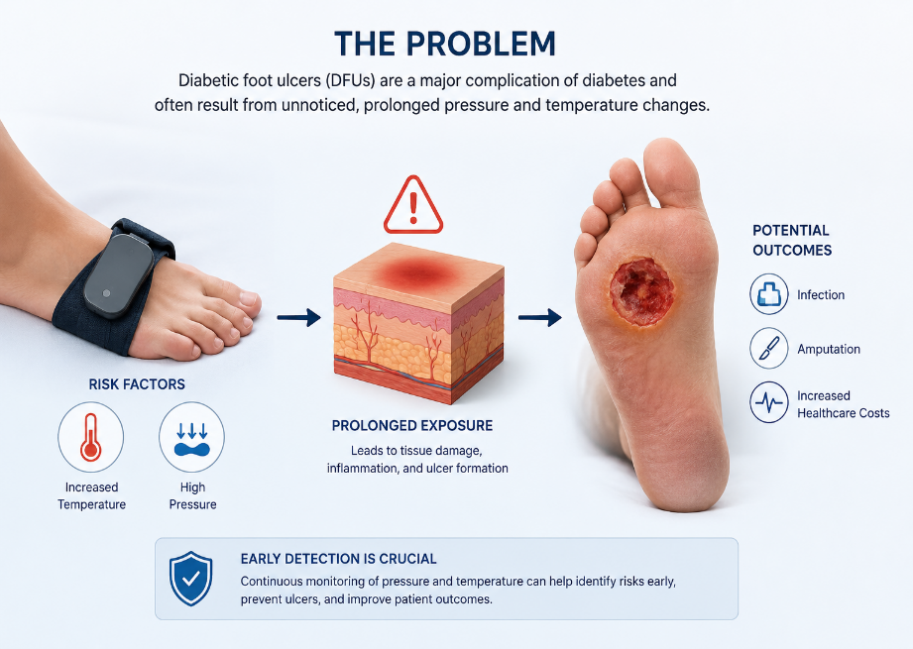
Additionally, other critical conditions such as stroke require early risk prediction based on multiple health parameters.
The lack of continuous monitoring and early warning systems creates a significant gap in patient care.
Figure 1Conceptual illustration of diabetic foot ulcer formation resulting from prolonged abnormal pressure and temperature changes.

Therefore, there is a strong need for a smart healthcare system capable of real-time monitoring, early detection, and predictive analysis using AI technologies.
1.1.2 Motivation
The motivation behind this project is to develop a smart, reliable, and scalable healthcare system that integrates traditional healthcare approaches with modern AI-based technologies.
The main motivations include:
• Early detection of diabetic foot ulcers using real-time sensor data

• AI-based classification and severity grading of diabetic foot ulcers
• Continuous monitoring of foot pressure and temperature

• Providing AI-assisted prediction for multiple healthcare conditions
• Supporting stroke risk prediction using patient health data
• Enhancing accessibility to healthcare services through mobile applications
• Reducing dependency on hospital visits by enabling remote monitoring
• Providing additional intelligent features such as healthcare analysis and intelligent recommendations
This project is also motivated by the growing need for digital healthcare transformation and smart medical systems that can assist both patients and healthcare professionals.
1.1.3 Objectives of the Project
The main objectives of this project are as follows:

Hardware and Embedded System Objectives
• Design and implement a Smart Insole system capable of measuring foot pressure and temperature using:
o FSR Pressure Sensor
o SHT31 Temperature Sensor
o ESP32 Microcontroller for wireless data transmission

Artificial Intelligence Objectives
• Develop an AI-based ulcer prediction model using Random Forest to analyze sensor readings and detect early diabetic foot ulcer risk
• Implement a diabetic foot ulcer image classification system using MobileNetV2 for ulcer severity grading (Grade 1 to Grade 4)
• Build a stroke prediction system based on patient healthcare parameters using machine learning algorithms
• Develop a general disease prediction system capable of predicting multiple healthcare conditions using Artificial Intelligence techniques

Mobile Application Objectives
• Design and implement a Flutter-based mobile healthcare application that includes:
o User authentication system
o Health dashboard
o Prediction result visualization
o Foot monitoring visualization
o Medical image upload functionality

Backend and System Integration Objectives
• Develop a backend infrastructure using FastAPI to support:
o Data processing
o API communication
o AI model integration
• Store and manage patient healthcare records securely and efficiently
• Integrate IoT technologies and Artificial Intelligence into a unified intelligent healthcare platform

Healthcare and User Experience Objectives
• Improve early medical intervention and reduce diabetic foot ulcer complications
• Enable real-time healthcare monitoring and abnormal reading alert generation
• Enhance healthcare accessibility through remote monitoring services
• Provide additional intelligent healthcare features such as:
o Nutrition planning
o Medical report analysis
o Future health simulation
o AI chatbot assistance
o AI result explanation
• Enhance user experience through an interactive and user-friendly mobile healthcare application
• Support healthcare professionals with AI-assisted healthcare decision-making tools
• Ensure system scalability and flexibility for future healthcare expansion
• Reduce healthcare costs through preventive healthcare monitoring and remote healthcare services

1.2 Literature Review and Related Studies
Recent advancements in healthcare technology have introduced various intelligent healthcare systems that combine Artificial Intelligence (AI), embedded systems, and mobile applications for disease prediction and patient monitoring. These technologies have significantly improved the efficiency of healthcare services by enabling real-time monitoring, automated diagnosis, and early detection of medical conditions.
Machine learning algorithms such as Random Forest have been widely applied in healthcare applications due to their high predictive accuracy, robustness, and ability to handle complex medical datasets. These models are commonly used in disease prediction systems including diabetes analysis, stroke prediction, and patient risk assessment.
In addition, deep learning architectures such as MobileNetV2 have achieved significant performance in medical image classification tasks. These models are especially effective in analyzing diabetic foot ulcer images and determining severity levels due to their ability to extract important visual features from medical images.
Several research studies have proposed wearable healthcare systems based on pressure and temperature sensors to monitor diabetic foot conditions. These systems aim to detect abnormal pressure distribution and temperature changes, which are considered early indicators of diabetic foot ulcer formation.
Despite the progress in smart healthcare technologies, many existing systems focus only on a single aspect of healthcare monitoring, such as either hardware-based sensing or software-based prediction. Few systems provide a fully integrated platform that combines embedded sensors, AI prediction models, medical image analysis, backend processing, and mobile healthcare applications within one unified system.
Therefore, this project aims to overcome these limitations by developing a comprehensive intelligent healthcare platform that integrates smart insole technology, machine learning prediction models, medical image classification, and mobile healthcare services to support early diagnosis and continuous patient monitoring.
The integration of these technologies provides a scalable, integrated and intelligent healthcare solution capable of improving patient care and reducing healthcare risks.

1.2.1 Historical Overview of Smart Healthcare Systems
Over the past decades, healthcare technologies have evolved significantly due to the integration of Artificial Intelligence (AI), Internet of Things (IoT), and wearable medical devices. Traditional healthcare systems mainly depended on manual diagnosis and periodic clinical examinations, which often delayed the detection of critical healthcare conditions.
With the advancement of embedded systems and wireless communication technologies, smart healthcare solutions began to emerge, enabling continuous patient monitoring and real-time data collection.
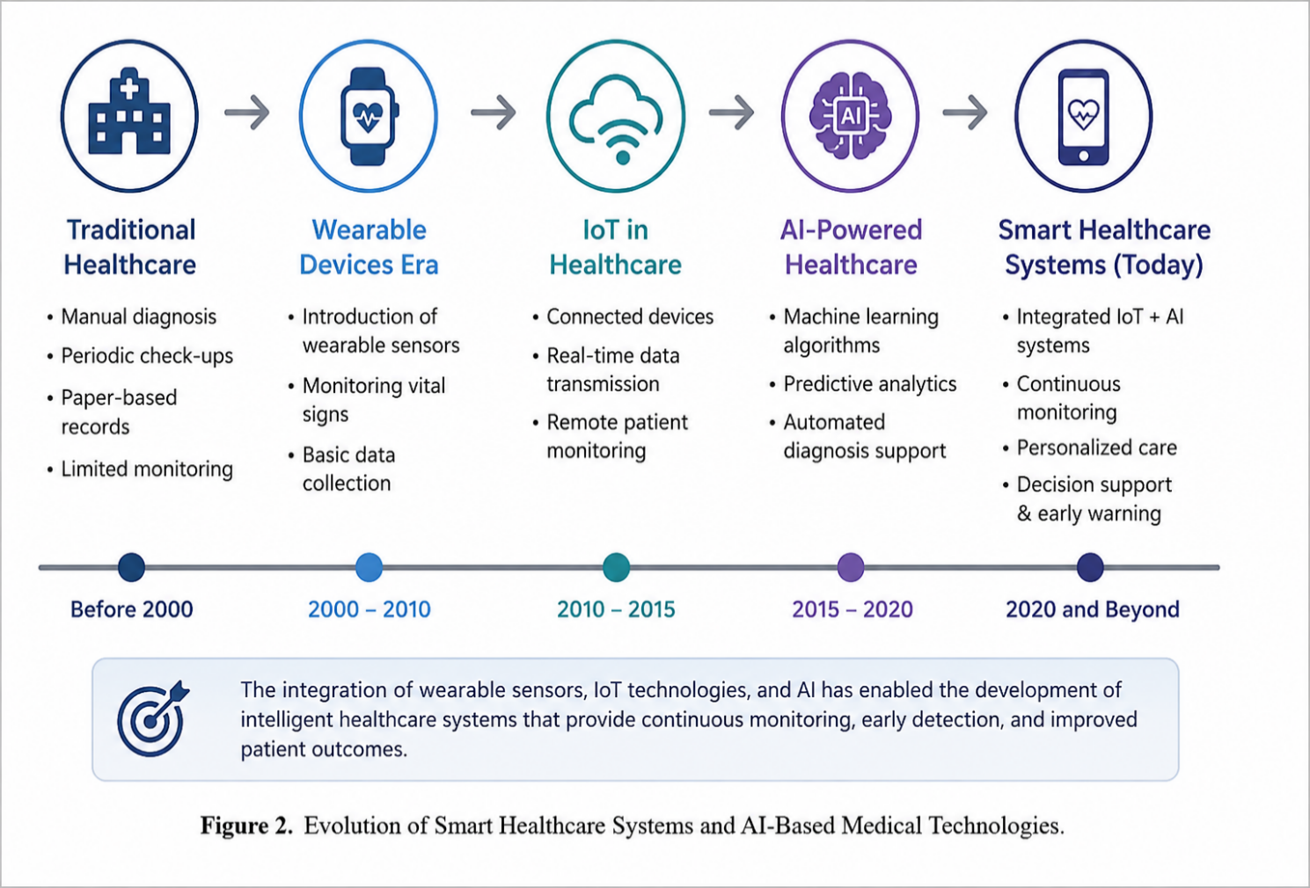
Wearable healthcare devices became increasingly important in monitoring physiological parameters such as heart rate, body temperature, blood pressure, and movement patterns.
Figure 2Evolution of Smart Healthcare Systems and AI-Based Medical Technologies.

1.2.2 Comparison Between Existing Related Studies and the Proposed System
Study | Technologies Used | Main Features | Limitations
Smart Insole-Based Plantar Pressure Analysis for Healthy and Diabetic Feet Classification (2024) | Smart Insole + Machine Learning | Dynamic plantar pressure analysis using embedded sensors | Focused only on pressure analysis without mobile healthcare integration (ResearchGate)
DFUNet: Convolutional Neural Networks for Diabetic Foot Ulcer Classification (2017) | CNN Deep Learning | Automated diabetic foot ulcer image classification | No IoT monitoring or mobile application support (arXiv)
AI-Enhanced Imaging for Diabetic Foot Ulcer Risk Assessment (2026) | Deep Learning + Thermal Imaging | DFU severity analysis using multimodal imaging | Focused mainly on image analysis without healthcare monitoring integration (arXiv)
Machine Learning for Diabetic Foot Care (2025) | Machine Learning Algorithms | Disease prediction and DFU risk assessment | Limited integration between AI models and wearable healthcare systems (Frontiers)
Proposed Intelligent Healthcare System | Smart Insole + AI + Mobile Application + FastAPI + Cloud Integration | Real-time healthcare monitoring, DFU prediction, image classification, stroke prediction, general disease prediction, chatbot assistance, medical report analysis, and mobile healthcare integration | Prototype system requiring future clinical validation

One of the major areas of development in smart healthcare is diabetic foot monitoring. Researchers introduced pressure-sensitive insoles and temperature monitoring systems to detect abnormal foot conditions associated with diabetic foot ulcers. Studies have shown that increased plantar pressure and abnormal temperature distribution are early indicators of ulcer formation.
In parallel, machine learning and deep learning techniques became widely used in medical diagnosis systems. Algorithms such as Random Forest demonstrated high predictive performance in disease prediction tasks due to their robustness and high classification accuracy. Similarly, convolutional neural networks (CNNs), including MobileNetV2, achieved significant performance in medical image classification applications such as diabetic foot ulcer grading and skin lesion detection.
Modern healthcare systems now combine wearable sensors, AI prediction models, cloud computing, and mobile applications to create integrated healthcare platforms capable of providing real-time monitoring, early diagnosis, and remote healthcare support.
The proposed project follows this modern healthcare approach by integrating smart insole technology, AI-based disease prediction, medical image analysis, and mobile healthcare services into a unified intelligent system.
These advancements have paved the way for intelligent healthcare systems capable of providing personalized, preventive and proactive healthcare services .

1.2.2 Comparison between Traditional and AI-Based Healthcare Systems
Traditional Healthcare Systems | AI-Based Healthcare Systems
Manual diagnosis | Automated prediction
Periodic monitoring | Real-time monitoring
Delayed detection | Early detection
Limited accessibility | Remote healthcare support
Higher workload | AI-assisted decision making

1.3 System Overview
The proposed system is a multi-layer intelligent healthcare platform that integrates embedded hardware, AI models, backend services, and a mobile application.

1.3.1 General Architecture of the Proposed System
The system consists of four primary components in addition to supporting healthcare services:
- Smart Insole (Embedded System)
  - Equipped with FSR pressure sensor and SHT31 temperature sensor
  - Collects real-time foot data
  - Sends data using ESP32 microcontroller

- AI Analysis Layer
  - Random Forest models for:
    - Ulcer prediction
    - Stroke prediction
    - General health prediction
  - MobileNetV2 model for image classification
- Backend System
  - Developed using FastAPI
  - Handles data processing and API communication
- Mobile Application
  - Built using Flutter
  - Provides healthcare Visualization, AI prediction results, and interactive healthcare services.
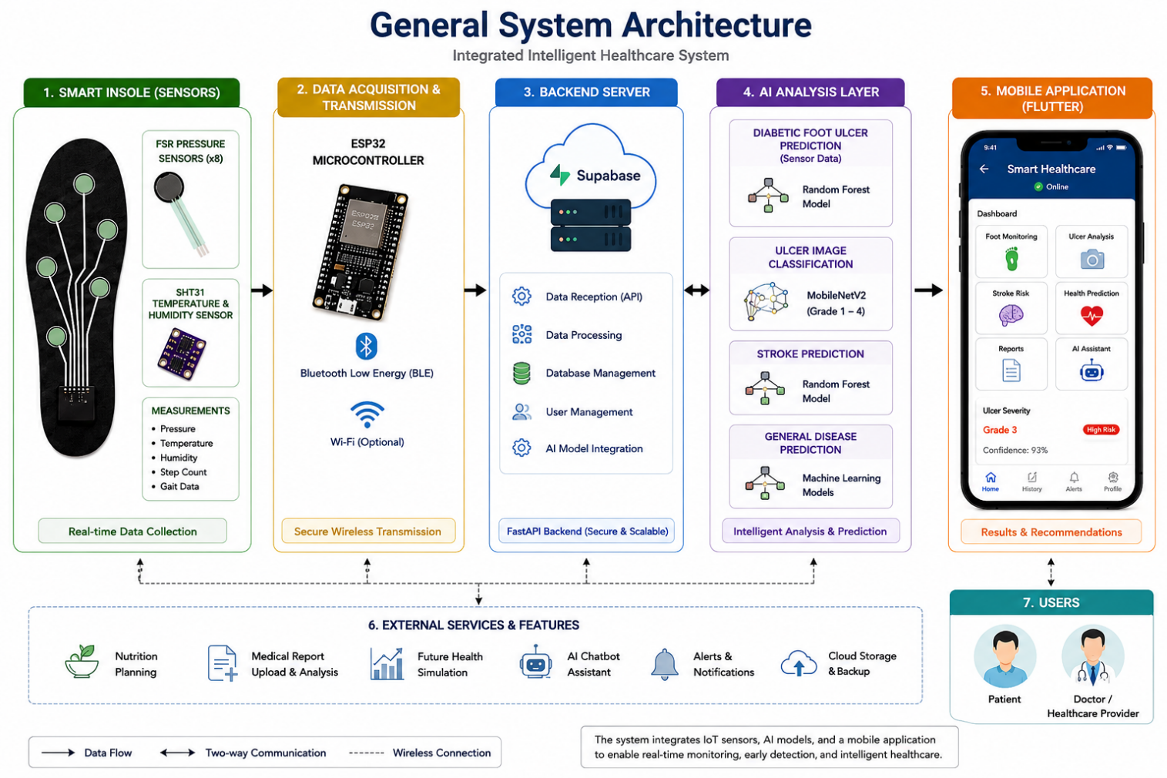
Figure 3Overall architecture of the proposed intelligent healthcare platform.

1.3.2 Description of Main Modules and Interactions
The proposed system operates through the following operational workflow:
- Real-time healthcare data is collected from the user’s foot using pressure and temperature sensors embedded within the Smart Insole subsystem.
- The ESP32 microcontroller transmits the collected sensor readings wirelessly to the backend infrastructure for processing and storage.
- The backend system processes the incoming healthcare data and forwards it to the appropriate Artificial Intelligence models for predictive analysis.
- The AI models generate healthcare predictions, classification results, and risk assessment outputs based on the received data.
- The generated results are transmitted to the mobile healthcare application through API communication services.
- Users can access healthcare predictions, monitoring information, alerts, and intelligent healthcare recommendations through the Flutter-based mobile application.
This integration ensures a seamless and efficient flow of healthcare data between embedded hardware, backend infrastructure, AI prediction modules, and mobile healthcare services, enabling real-time healthcare monitoring and predictive healthcare analysis.

Chapter 2

System Analysis and Design

2. System Analysis and Design
This chapter presents the analysis and design of the proposed intelligent healthcare system for diabetic foot ulcer prediction and monitoring. The system integrates embedded sensing technology, Artificial Intelligence (AI), medical image analysis, backend processing, and mobile healthcare services into a unified platform capable of real-time monitoring and predictive healthcare analysis.
The proposed system was designed to address the limitations of traditional healthcare monitoring systems by providing continuous data acquisition, intelligent prediction, remote accessibility, and AI-assisted healthcare support. The architecture combines Internet of Things (IoT) technologies with machine learning and deep learning models to support preventive healthcare, early diagnosis and AI-assisted healthcare decision-making.
The system consists of several interconnected modules, including the Smart Insole sensing module, AI prediction models, medical image classification module, backend services, and the mobile application layer. Each module performs a specific role within the overall healthcare framework while maintaining continuous communication with the other system components.
The Smart Insole is responsible for collecting real-time physiological data related to foot pressure and temperature distribution using embedded sensors. The collected data is transmitted through the ESP32 microcontroller to the backend server, where preprocessing and predictive analysis are performed using AI models.
In addition to sensor-based prediction, the system includes a diabetic foot ulcer image classification module capable of analyzing ulcer images and determining severity grades using a deep learning model based on MobileNetV2 architecture. The system also incorporates a stroke prediction module and a general disease prediction to provide a more comprehensive healthcare platform.
The following sections explain the detailed analysis, architecture, data processing stages, and interaction mechanisms of each subsystem.

2.1 Smart Insole Data Processing
The Smart Insole subsystem represents the core hardware component of the proposed healthcare platform. It was designed to continuously monitor foot conditions associated with diabetic foot ulcer formation through real-time sensing and intelligent analysis.
The Smart Insole integrates pressure and temperature sensors embedded inside the insole structure to collect physiological measurements from different foot regions. These measurements are considered critical healthcare indicators for detecting abnormal conditions related to diabetic foot ulcers.

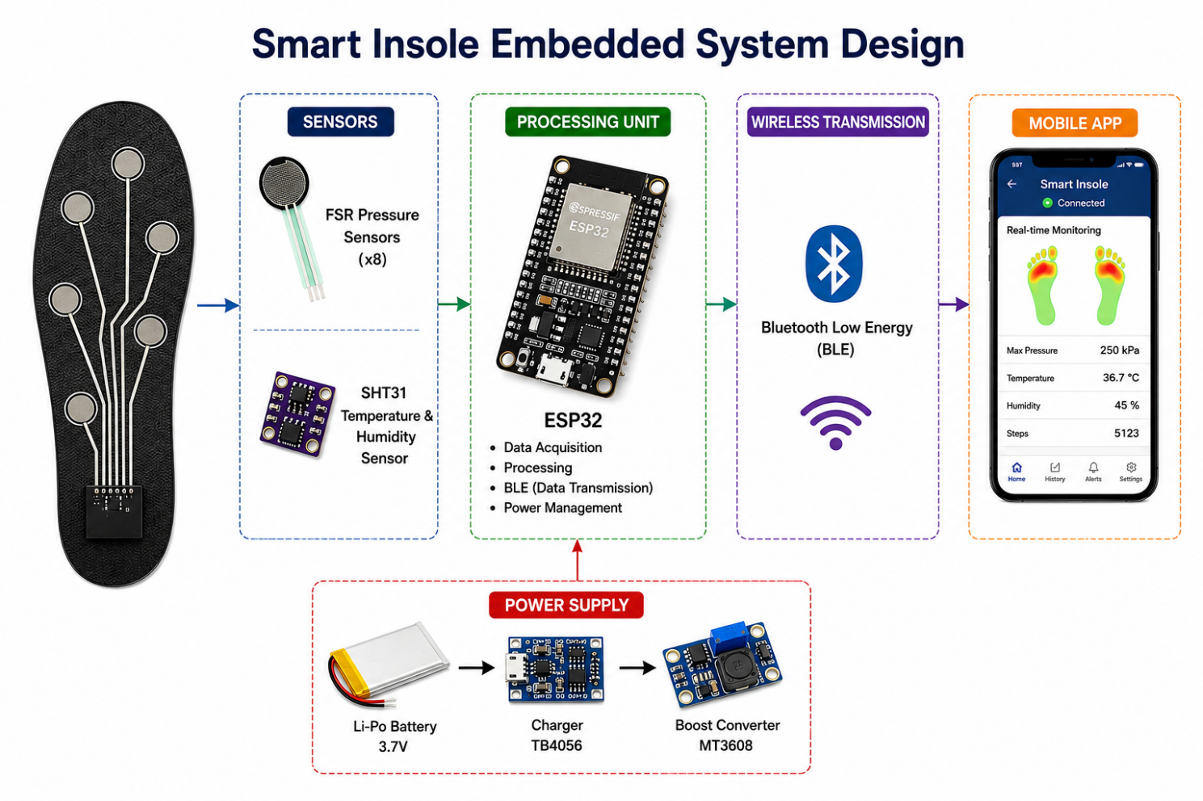
Figure 4Smart Insole Embedded System Architecture

Patients with diabetes often suffer from peripheral neuropathy and poor blood circulation, which may lead to abnormal plantar pressure distribution and localized temperature changes. Continuous monitoring of these parameters enables early identification of potential ulcer formation before severe complications occur.
The Smart Insole subsystem operates as an IoT-enabled wearable healthcare device capable of collecting, processing, and transmitting sensor data to the backend server through wireless communication. The integration of embedded hardware and AI-based analysis enables continuous healthcare monitoring without requiring continous clinical supervision.
The collected sensor readings are transmitted using the ESP32 microcontroller, which acts as the communication and processing unit of the embedded system. The backend server receives the data and forwards it to the AI prediction model for ulcer risk analysis.
The Smart Insole subsystem was designed with the following objectives:
- Continuous real-time monitoring of foot conditions
- Detection of abnormal pressure distribution
- Detection of abnormal temperature variations
- Early prediction of diabetic foot ulcer risk
- Wireless transmission of sensor readings
- Integration with AI prediction models
- Support for remote healthcare monitoring
The overall data processing workflow includes sensor acquisition, signal preprocessing, feature extraction, predictive analysis, and prediction result transmission to the mobile application.

2.1.1 Pressure and Temperature Sensing Mechanism
The sensing mechanism of the Smart Insole is based on the integration of pressure and temperature sensors positioned at critical regions of the foot. These sensors continuously measure physiological changes associated with diabetic foot complications.
The system uses Force Sensitive Resistor (FSR) sensors to measure plantar pressure distribution. FSR sensors are lightweight, flexible, and well-suited for wearable healthcare applications due to their ability to detect variations in applied force.
The resistance value of the FSR sensor changes according to the amount of pressure applied to the sensor surface. Higher pressure levels produce lower resistance values, allowing the system to estimate plantar pressure intensity at different foot regions. 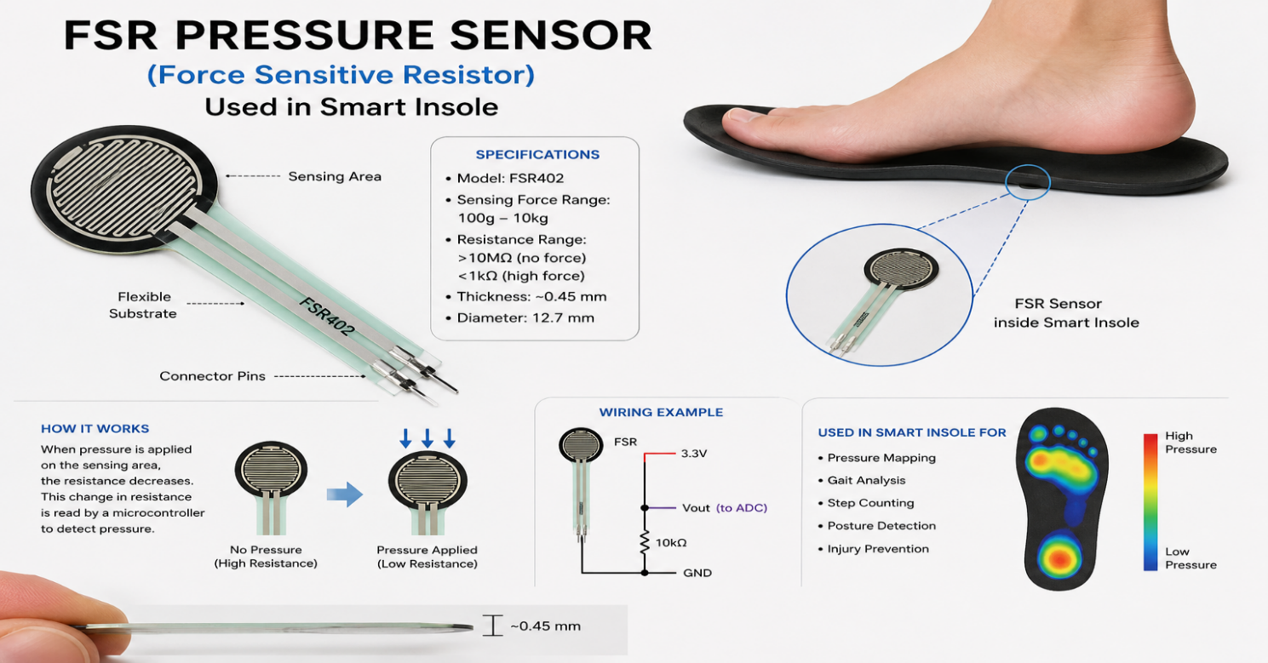
Figure 5FSR Pressure Sensor Used in Smart Insole.
The sensors are strategically positioned inside the insole to monitor areas that are high-risk foot regions to ulcer formation, including:
- Heel region
- Metatarsal region
- Toe region
- Midfoot region
Continuous monitoring of these areas allows the system to identify abnormal pressure concentration patterns that may increase ulcer risk.
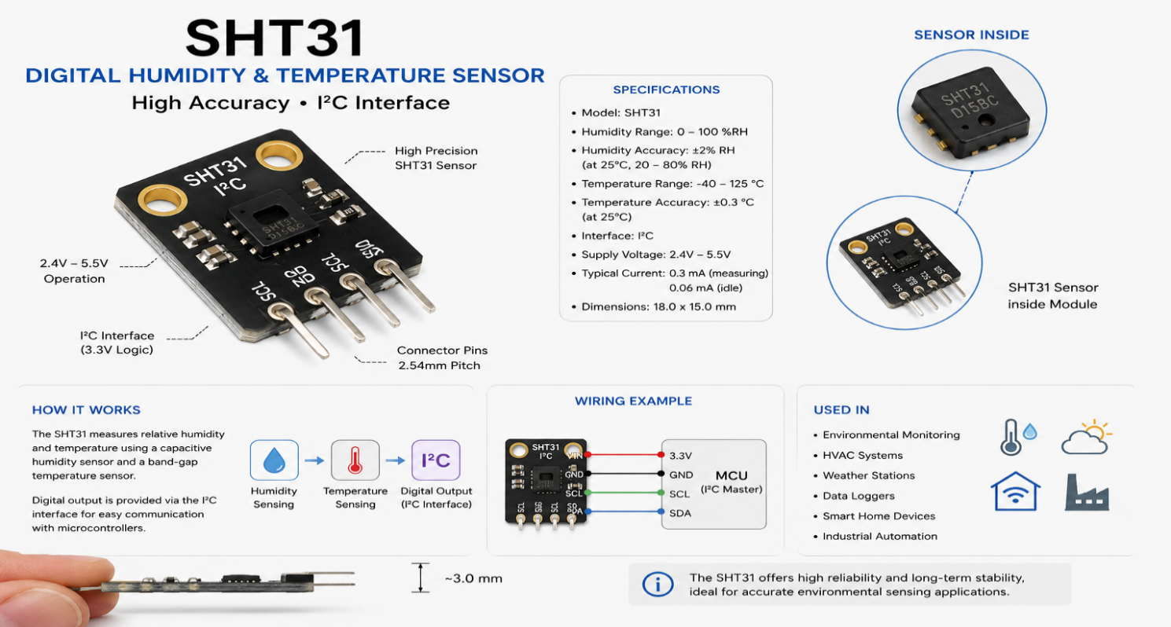
In addition to pressure monitoring, the system integrates the SHT31 temperature sensor to measure foot temperature variations. Temperature monitoring plays an important role in diabetic foot analysis because localized temperature increases may indicate inflammation, localized tissue stress, or early ulcer development.
Figure 6SHT31 Temperature Sensor
The SHT31 sensor provides accurate digital temperature measurements with high stability and low power consumption, making it suitable for wearable healthcare applications.
Both sensor types are connected to the ESP32 microcontroller, which performs the following functions:
- Sensor data acquisition
- Analog-to-digital conversion
- Data formatting
- Wireless communication
- Transmission to the backend server
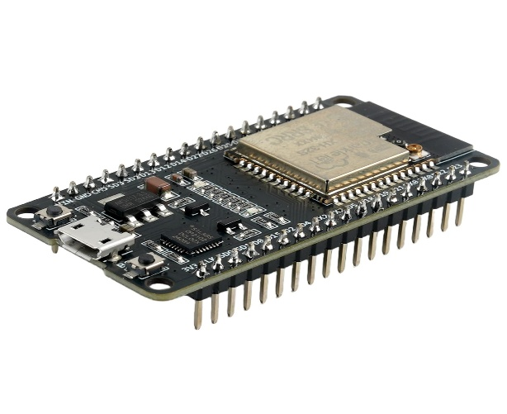
The ESP32 was selected due to its integrated Wi-Fi capability, high processing efficiency, low power consumption, and compatibility with IoT healthcare systems.
Figure 7ESP32 Microcontroller for Data Transmission

The sensing process operates continuously during system usage, enabling real-time monitoring and real-time detection of abnormal readings.

2.1.2 Data Preprocessing and Feature Extraction
The raw sensor data collected from the Smart Insole cannot be directly utilized for AI prediction because sensor readings may contain noise, fluctuations, or incomplete values. Therefore, a preprocessing stage is required to improve data quality and prepare the information for machine learning analysis.
The preprocessing stage begins with data cleaning, where invalid or inconsistent sensor readings are removed or corrected. Signal smoothing and noise reduction techniques are applied to stabilize sensor fluctuations and improve measurement reliability.
After cleaning the data, normalization is performed to scale sensor values into a consistent numerical range. This process improves the performance and stability of the machine learning model by preventing large-scale numerical variations between features.
Feature extraction is then applied to identify meaningful healthcare patterns from the collected sensor readings. Several important features are extracted from pressure and temperature measurements, including:
- Average pressure values
- Maximum pressure values
- Pressure distribution patterns
- Temperature averages
- Temperature differences between foot regions
- Pressure variation over time
- Abnormal pressure concentration areas
These extracted features represent critical healthcare indicators used by the AI prediction model to estimate ulcer risk levels.
The preprocessing stage also includes data organization and formatting before transmission to the prediction layer. Structured feature vectors are generated and forwarded to the Random Forest model for analysis.
Effective preprocessing significantly improves model prediction accuracy and enhances the reliability of the healthcare monitoring system.

2.1.3 AI-Based Ulcer Risk Prediction Logic
The ulcer risk prediction subsystem is responsible for analyzing processed sensor data and estimating the probability of diabetic foot ulcer formation.
The system uses the Random Forest machine learning algorithm due to its high classification performance, robustness, and ability to handle complex clinical healthcare datasets. Random Forest is an ensemble learning method that combines multiple decision trees to improve prediction accuracy and reduce overfitting.
The prediction model was trained using healthcare datasets containing pressure and temperature-related features associated with diabetic foot conditions.
The training process enabled the model to learn predictive relationships between physiological measurements and ulcer risk levels.
The prediction workflow operates through the following stages:
- Sensor data collection
- Data preprocessing and normalization
- Feature extraction
- Input vector generation
- AI model prediction
- Risk classification
- Result transmission to the mobile application
The Random Forest model analyzes the extracted features and generates prediction results indicating whether the patient is at low, medium, or high risk of ulcer formation.
The prediction results are then transmitted to the mobile application, where users can visualize their healthcare condition and receive medical recommendations.
The AI prediction logic enables:
- Early ulcer detection
- Continuous patient monitoring
- Automated healthcare analysis
- Real-time risk assessment
- Reduction of ulcer-related complications

The integration of AI within the Smart Insole subsystem improves preventive healthcare capabilities and supports proactive medical intervention before severe diabetic foot ulcer progression occurs.

2.2 Diabetic Foot Ulcer Image Classification
The Diabetic Foot Ulcer Image Classification module represents one of the major AI-driven components of the proposed healthcare system. This module was developed to assist in the automated analysis and grading of diabetic foot ulcer images using deep learning-based image analysis techniques.
Diabetic foot ulcers are considered among the most severe complications associated with diabetes mellitus. Delayed diagnosis and inaccurate assessment of ulcer severity may lead to serious complications including infection, tissue damage, and lower limb amputation. Therefore, accurate ulcer classification and severity assessment are essential for supporting early medical intervention and improving patient outcomes.
Traditional ulcer assessment mainly depends on manual clinical examination performed by healthcare professionals. Although medical expertise plays an important role in diagnosis, manual assessment may be computationally and clinically time-consuming and subject to variability between clinicians. In addition, continuous medical supervision may not always be available for patients in remote or underserved areas.
To overcome these limitations, the proposed system integrates an AI-based medical image classification module capable of automatically analyzing ulcer images and determining severity levels. The module uses a deep learning model based on the MobileNetV2 architecture due to its high classification performance, computational efficiency, and suitability for mobile healthcare applications.
The classification system was designed to analyze diabetic foot ulcer images and classify them into four severity grades ranging from Grade 1 to Grade 4. The output generated by the model assists healthcare professionals in ulcer severity assessment and AI-assisted clinical decision support.
The image classification module operates through several stages including image acquisition, preprocessing, feature extraction, deep learning-based inference, severity grading, and result interpretation.
The model was trained using a labeled diabetic foot ulcer image dataset containing four severity grades.
The main objectives of this module include:
- Automated diabetic foot ulcer analysis
- Early ulcer severity detection
- Reduction of manual diagnostic workload
- Support for healthcare decision-making
- Fast and accurate image classification
- Integration with mobile healthcare services
- Assistance in remote healthcare monitoring
The integration of deep learning within the proposed healthcare platform enhances the intelligence and automation capabilities of the overall system.
The developed MobileNetV2 model achieved high classification accuracy and predictive performance during evaluation using accuracy, precision, recall, and F1-score metrics.

2.2.1 Image Input and Preprocessing
The first stage of the image classification pipeline involves image acquisition and preprocessing. This stage is essential for improving medical image quality, standardizing input data, and enhancing the performance of the deep learning model.
The system allows users to upload diabetic foot ulcer images through the mobile application interface. The uploaded images are transmitted to the backend infrastructure, where preprocessing operations are applied before classification.
Medical images collected from different devices may vary in resolution, brightness, orientation, and image quality. These variations can negatively affect the performance of the deep learning classification model if preprocessing is not properly applied. Therefore, preprocessing is considered a critical step in preparing the dataset for reliable AI analysis.
The preprocessing stage includes several operations designed to improve image consistency and reduce unwanted image variations.
These operations include:
- Image resizing
- Image normalization
- Noise reduction
- Pixel value scaling
- Image formatting and standardization
Image resizing is performed to ensure that all images match the input dimensions required by the MobileNetV2 model. Standardizing image size improves computational efficiency and enables consistent feature extraction across all samples.
Normalization is applied to scale pixel intensity values into a unified numerical range. This process improves training stability and enhances model stability during deep learning analysis.
Noise reduction techniques help eliminate unnecessary image artifacts, illumination inconsistencies, background disturbances and improve medical image clarity.
Medical images may contain lighting inconsistencies, shadows, or background variations that could interfere with feature extraction. Preprocessing minimizes these issues and improves model reliability.

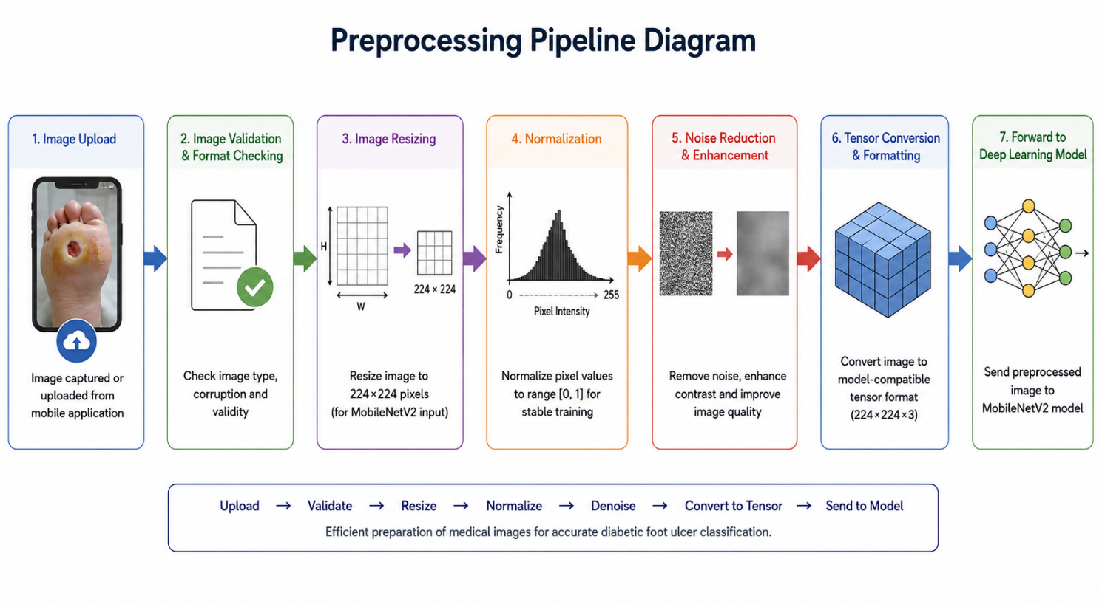
After preprocessing, the images are converted into structured tensor representations suitable for deep learning analysis. The processed images are then forwarded to the MobileNetV2 classification model.
Figure 8Medical Image Preprocessing Pipeline for Diabetic Foot Ulcer Classification

The preprocessing pipeline significantly improves classification performance by ensuring that the model receives clean and standardized image inputs. Proper preprocessing also helps reduce overfitting and improves model generalization capability when handling unseen ulcer images.

The complete preprocessing workflow can be summarized as follows:
- Image upload from mobile application
- Image validation and format checking
- Image resizing and normalization
- Noise reduction and enhancement
- Conversion into model-compatible format
- Transmission to the deep learning model
This pipeline ensures efficient preparation of medical images before the classification process begins.

2.2.2 Severity Grading (Grade 1–4 Classification)
The severity grading subsystem is responsible for classifying diabetic foot ulcer images into different severity levels using deep learning techniques. Accurate ulcer grading plays a critical role in determining the appropriate medical response and evaluating the progression of the condition.
The proposed system uses the MobileNetV2 convolutional neural network architecture for ulcer image classification. MobileNetV2 was selected because it provides high classification accuracy while maintaining computational efficiency suitable for mobile and embedded healthcare applications.
Convolutional Neural Networks (CNNs) are widely used in medical image analysis because of their ability to automatically extract critical visual features from images.
These networks learn complex image patterns such as tissue abnormalities, color variations, wound boundaries, and ulcer depth characteristics.
The training process of the model was performed using publicly available diabetic foot ulcer image datasets obtained from Kaggle. The dataset contained ulcer images categorized into multiple severity levels representing different stages of ulcer progression.
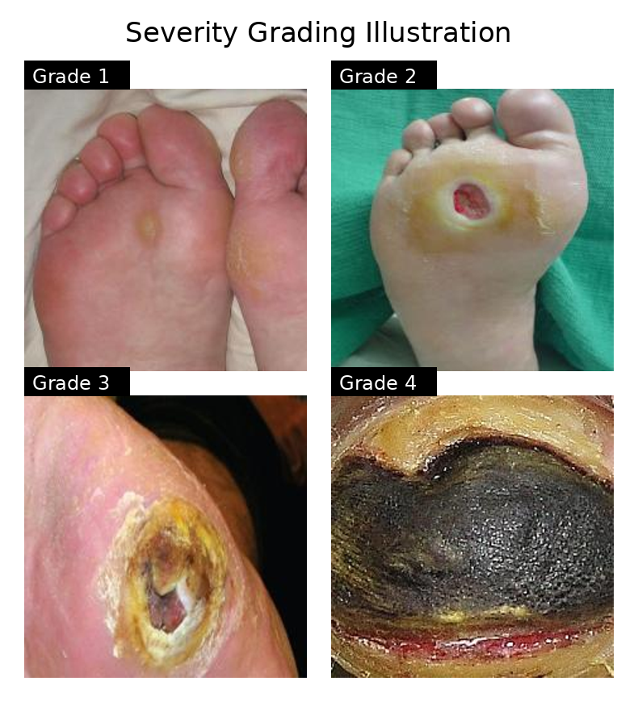
Figure 9DFU Severity Grading Illustration.

During training, the model learned critical visual features associated with ulcer severity through repeated exposure to labeled training samples. The deep learning model automatically extracted discriminative features without requiring manual feature extraction techniques.
The classification system categorizes ulcer images into four severity grades:
Diabetic Foot Ulcer Severity Grading Description
Grade | Description
Grade 1 | Mild ulcer condition with limited tissue involvement
Grade 2 | Moderate ulcer with deeper tissue damage
Grade 3 | Advanced ulcer with increased tissue deterioration
Grade 4 | Severe ulcer condition with high medical risk

The model analyzes image characteristics and generates classification probability scores for each severity class. The class with the highest probability is selected as the final prediction result.

The grading mechanism enables:
- Automated ulcer severity assessment
- Faster healthcare image analysis
- Reduction of diagnostic delays
- Improved healthcare monitoring
- Support for early medical intervention

The MobileNetV2 model achieved high classification performance during testing and validation stages, demonstrating strong predictive capability in recognizing diabetic foot ulcer severity patterns.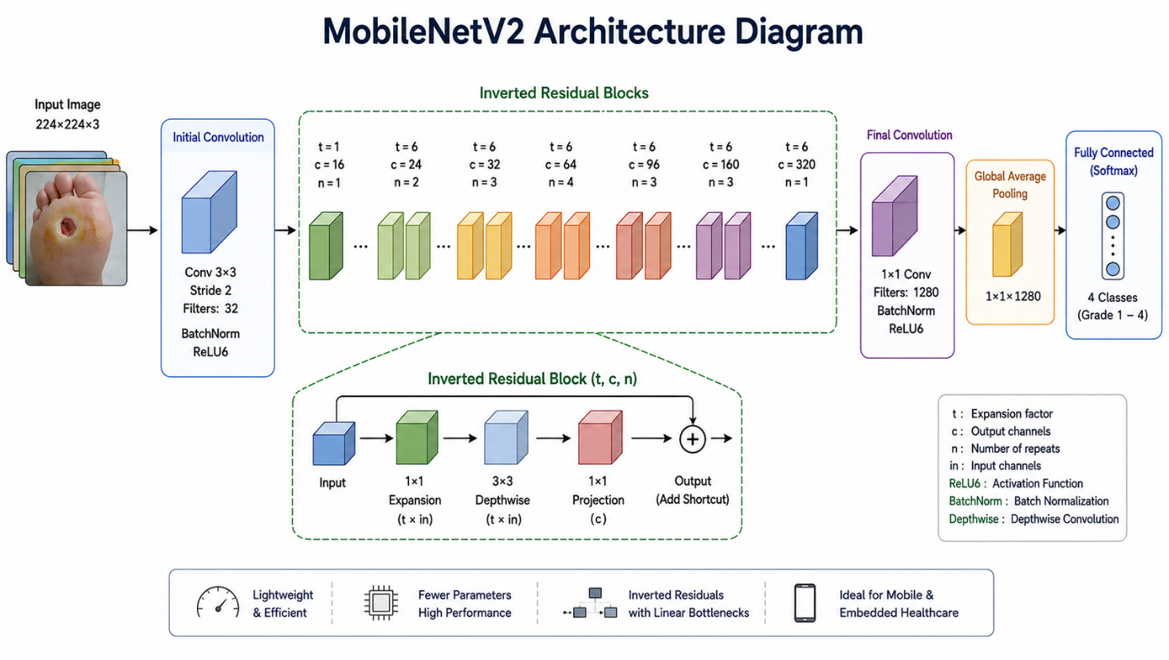
Figure 10MobileNetV2 Architecture for DFU Classification.

The lightweight architecture of MobileNetV2 also makes it suitable for deployment in real-time healthcare systems and mobile-based medical applications.
The integration of AI-based severity grading improves the intelligence of the proposed healthcare platform and enhances the automation capabilities of medical image analysis.

2.2.3 Model Output Interpretation
After image classification is completed, the prediction results generated by the deep learning model are processed, analyzed and interpreted before being displayed to the user through the mobile application.
The model output consists of probability values representing the likelihood of the input image belonging to each ulcer severity grade. These probabilities are generated using the Softmax activation function located at the output layer of the classification model.
The severity class with the highest probability score is selected as the final classification result. The predicted grade is then transmitted to the backend system and displayed within the mobile healthcare application.
The result interpretation subsystem was designed to provide users with understandable and clinically interpretable healthcare information rather than displaying raw numerical outputs only. This improves interpretability and user trust in the AI system.
The displayed output includes:
- Predicted ulcer severity grade
- Prediction confidence level
- Risk indication
- Basic healthcare recommendation
- Visual result representation
The system may also provide alert notifications for severe ulcer conditions requiring immediate medical attention. This functionality supports proactive healthcare intervention and helps reduce the risk of serious complications.
In addition to patient support, the interpretation module assists healthcare professionals by providing preliminary AI-assisted assessment results that may support clinical decision-making.
The output interpretation process follows several stages:
- Deep learning model generates prediction probabilities
- Highest probability class is selected
- Prediction confidence scores are generated
- Result is transmitted to the backend server
- Mobile application displays the final output
- User receives healthcare feedback and recommendations
The integration of intelligent interpretation mechanisms improves system usability and enhances communication between AI technologies and end users.

The proposed image classification module demonstrates how deep learning can be effectively integrated into smart healthcare systems to support AI-assisted medical diagnosis, remote monitoring, and early medical intervention for diabetic foot ulcer patients.

2.3 Stroke Prediction System
The Stroke Prediction System represents one of the intelligent healthcare modules integrated within the proposed platform. This subsystem was developed to predict the probability of stroke occurrence using machine learning techniques and patient health information.
Stroke is considered one of the leading causes of death and long-term disability worldwide. Early prediction of stroke risk can significantly improve medical intervention, reduce stroke-related complications, and increase patient survival rates. However, traditional stroke assessment methods mainly depend on periodic clinical evaluation and manual medical analysis performed by healthcare professionals.
The proposed system integrates an AI-based prediction model capable of analyzing multiple health parameters and automatically estimating stroke risk levels. The prediction subsystem aims to support preventive healthcare by providing early warning indicators and intelligent risk assessment.
The system utilizes machine learning algorithms to identify predictive relationships between patient medical data and stroke probability. The generated prediction results assist both patients and healthcare professionals in understanding potential health risks and making informed medical decisions.
The main objectives of the Stroke Prediction System include:
• Early stroke risk prediction
• Automated health risk assessment
• AI-assisted medical decision support
• Reduction of delayed stroke diagnosis
• Integration with mobile healthcare services
• Continuous health monitoring and analysis
The stroke prediction module enhances the intelligence of the proposed healthcare platform by combining machine learning techniques with intelligent healthcare support services.

2.3.1 Input Feature Selection
The prediction accuracy of machine learning systems strongly depends on the quality and relevance of input features used during training and inference stages. Therefore, selecting appropriate healthcare parameters is considered an essential step in developing a reliable stroke prediction model.
The proposed system utilizes multiple patient health attributes associated with stroke occurrence.
These features were selected based on medical relevance and their contribution to stroke risk analysis according to clinical healthcare studies and publicly available medical datasets.

The input features used by the prediction model include:
• Gender
• Weight and height measurements
• Body Mass Index (BMI)
• Sleep duration
• Smoking status
• Alcohol consumption
• Heart disease history
• Asthma condition
• Kidney disease condition
• Difficulty walking
These healthcare parameters provide critical healthcare indicators associated with multiple chronic diseases and general patient health conditions.
The collected features assist the machine learning model in identifying predictive healthcare patterns and generating accurate disease prediction results.
Before being forwarded to the machine learning model, the collected data undergoes preprocessing operations including:
• Missing value handling
• Feature encoding
• Data normalization
• Numerical transformation
• Input validation
Feature preprocessing improves model stability and improves prediction reliability by ensuring consistent and standardized healthcare data.
The selected features provide important medical indicators that help the machine learning model recognize patterns associated with stroke risk and patient health conditions.

2.3.2 AI Prediction Model
The proposed Stroke Prediction System utilizes the Random Forest machine learning algorithm for stroke risk prediction. Random Forest was selected because of its high classification accuracy, robustness, scalability, and ability to handle complex healthcare datasets containing both numerical and categorical variables.
Random Forest is an ensemble learning technique that combines multiple decision trees to generate more reliable and stable healthcare prediction results. The algorithm improves prediction performance by reducing overfitting and enhancing generalization capability.
The stroke prediction model was trained using publicly available healthcare datasets containing patient medical information and stroke-related records. During training, the model learned predictive relationships between patient health parameters and stroke probability.
The prediction workflow consists of several stages:
- Patient healthcare data collection
- Data preprocessing and feature preparation
- Feature transmission to the Random Forest model
- Prediction probability calculation
- Stroke risk classification
- Result delivery to the mobile application

The Random Forest model analyzes patient information and generates prediction probabilities indicating the probability of stroke occurrence. The final prediction result is categorized into risk levels such as low risk, moderate risk, or high risk.
The integration of machine learning within the healthcare platform enables fast and AI-assisted stroke risk assessment while supporting preventive healthcare strategies and early medical intervention.

2.3.3 Result Interpretation
After the prediction process is completed, the generated results are interpreted and presented to the user through the mobile healthcare application in a simplified and clinically interpretable format.
The result interpretation subsystem converts raw machine learning outputs into clinically meaningful healthcare information that can assist users and healthcare professionals in understanding stroke risk conditions.
The displayed output includes:
• Predicted stroke risk level
• Prediction confidence score
• Risk severity classification
• Medical recommendations and guidance
• Warning notifications for high-risk conditions
The system may also provide alert notifications when critical stroke risk conditions are detected.
These alerts assist users to seek immediate medical consultation and continuous healthcare monitoring.
The interpretation process follows several stages:
- Machine learning model generates prediction probabilities
- Risk level is determined based on probability score
- Results are processed by the backend system
- Prediction results are transmitted to the mobile application
- User receives healthcare recommendations and warnings
The integration of intelligent interpretation mechanisms improves healthcare awareness and supports AI-assisted preventive healthcare and early medical intervention services.
The Stroke Prediction System demonstrates how machine learning can be effectively integrated into modern healthcare platforms to support automated risk assessment, remote monitoring, and early medical intervention.

2.4 General Health Prediction System
The General Health Prediction System represents an additional intelligent healthcare module integrated within the proposed platform. This subsystem was developed to provide automated prediction and preliminary assessment of multiple health conditions using machine learning techniques and patient medical information.
The primary objective of this module is to support preventive healthcare by enabling early detection of potential diseases and assisting users in understanding their general health conditions before complications become severe. The system utilizes AI-based prediction models capable of analyzing healthcare parameters and identifying predictive healthcare patterns associated with different medical conditions.
Unlike traditional healthcare approaches that rely mainly on manual diagnosis and hospital visits, the proposed system provides a AI-assisted digital healthcare solution capable of performing automated health analysis through a mobile healthcare platform.
The General Health Prediction System was designed to predict multiple health conditions including:
• Cancer
• Diabetes
• Asthma
• Hypertension
• Obesity
• Arthritis
• Healthy condition detection
The integration of this subsystem enhances the scalability and intelligence of the proposed healthcare platform by expanding its healthcare monitoring and disease prediction and intelligent healthcare analysis capabilities.

2.4.1 Health Data Collection and Feature Processing
The performance and reliability of machine learning prediction systems strongly depend on the quality of healthcare data used during training and prediction stages. Therefore, collecting and preprocessing relevant patient health information is considered an essential component of the proposed system.
The General Health Prediction System collects healthcare parameters through the mobile application interface, where users provide medical and physiological information required for prediction analysis.
The collected healthcare features may include:
• Glucose level
• Blood pressure
• Oxygen saturation level (SpO2)
• Length of stays
• Cholesterol level
• Triglycerides level
• HbA1C level
• Sleep hours
• Smoking status
• Alcohol consumption
• Family medical history
The collected information undergoes several preprocessing operations before being forwarded to the machine learning model.
These preprocessing operations include:
• Missing data handling
• Feature normalization
• Numerical scaling
• Categorical feature encoding
• Input validation and formatting
Feature preprocessing helps improve prediction stability and enhances model reliability by ensuring standardized healthcare data representation.
The processed healthcare data is then converted into structured numerical feature vectors suitable for machine learning analysis and disease prediction.

2.4.2 Machine Learning Prediction Model
The proposed healthcare platform utilizes machine learning algorithms to perform general disease prediction and health condition assessment. The AI prediction model was designed to analyze healthcare parameters and identify predictive healthcare relationships associated with multiple diseases.

Machine learning techniques provide efficient healthcare analysis by automatically recognizing patterns within medical datasets and generating prediction results without requiring extensive manual clinical analysis.
The model was trained using healthcare datasets containing patient medical information and disease-related records representing multiple health conditions. During training, the algorithm learned important healthcare patterns associated with diseases such as cancer, diabetes, asthma, hypertension, obesity, and arthritis.
The prediction workflow includes several stages:
- Healthcare data collection
- Data preprocessing and feature preparation
- Feature transmission to the AI model
- Disease probability estimation
- Health condition classification
- Result transmission to the mobile application
The machine learning model generates prediction probabilities for multiple disease classes. The disease category with the highest probability score is selected as the final prediction result.
The integration of machine learning within the healthcare platform enables fast and AI-assisted disease prediction while supporting preventive healthcare strategies and continuous health monitoring.

2.4.3 Result Interpretation and Healthcare Recommendations
After prediction analysis is completed, the generated outputs are interpreted and displayed to the user through the mobile healthcare application in a simplified and clinically interpretable format.
The interpretation subsystem converts raw machine learning outputs into clinically meaningful healthcare information that can assist users in evaluating their general health conditions and potential medical risks.
The displayed output includes:
• Predicted disease or health condition
• Prediction confidence score
• Risk severity level
• Medical recommendations and guidance
• Warning and alert notifications for critical conditions
If abnormal health conditions are detected, the system may provide alert notifications assisting users to seek immediate medical consultation and continuous healthcare monitoring.
The interpretation process follows several stages:
- Machine learning model generates disease probabilities
- Highest probability class is selected
- Backend system processes prediction results
- Results are transmitted to the mobile application
- User receives healthcare feedback and recommendations
The intelligent interpretation subsystem improves healthcare awareness and enhances communication between AI technologies and healthcare users.
The General Health Prediction System demonstrates how machine learning can be integrated into modern healthcare platforms to support automated disease prediction, preventive healthcare monitoring, and AI-assisted medical guidance.

Chapter 3

Proposed Intelligent Healthcare System

3. Proposed Intelligent Healthcare System
The proposed intelligent healthcare system was designed as an integrated smart medical platform that combines Internet of Things (IoT) technologies, embedded systems, mobile healthcare applications, and artificial intelligence techniques to support diabetic foot ulcer prediction and prevention, health monitoring, and disease prediction.
The system integrates multiple intelligent healthcare modules within a unified architecture capable of collecting physiological data, processing healthcare data, performing AI-based analysis, and providing real-time healthcare monitoring through a mobile application interface.
The proposed platform aims to improve preventive healthcare services by enabling continuous patient monitoring, automated medical analysis, early risk prediction, and remote healthcare support. The system architecture was developed to ensure scalability, efficiency, reliability, and compatibility with real-time intelligent healthcare environments.
The healthcare platform combines smart wearable technologies with machine learning and deep learning models to provide AI-assisted healthcare support for diabetic patients and general healthcare monitoring.
The proposed system consists of several interconnected modules including the Smart Insole subsystem, mobile healthcare application, backend services, AI prediction models, and cloud-based healthcare database management.

3.1 System Modules Overview
The proposed healthcare platform is composed of multiple integrated modules that operate collaboratively to provide intelligent healthcare monitoring and automated medical analysis. Each subsystem performs specialized healthcare tasks that contribute to the overall functionality of the healthcare platform.
The system modules communicate through secure data transmission mechanisms and centralized backend services to ensure efficient healthcare data processing and real-time healthcare response generation.

3.1.1 Smart Insole Module
The Smart Insole Module represents the embedded healthcare monitoring subsystem of the proposed platform. This module was designed to continuously monitor physiological conditions associated with diabetic foot complications using wearable sensor technologies.
The smart insole integrates multiple Force Sensitive Resistor (FSR) pressure sensors and SHT31 temperature sensors distributed across different foot regions to measure pressure distribution and temperature variations during patient movement and daily activities.
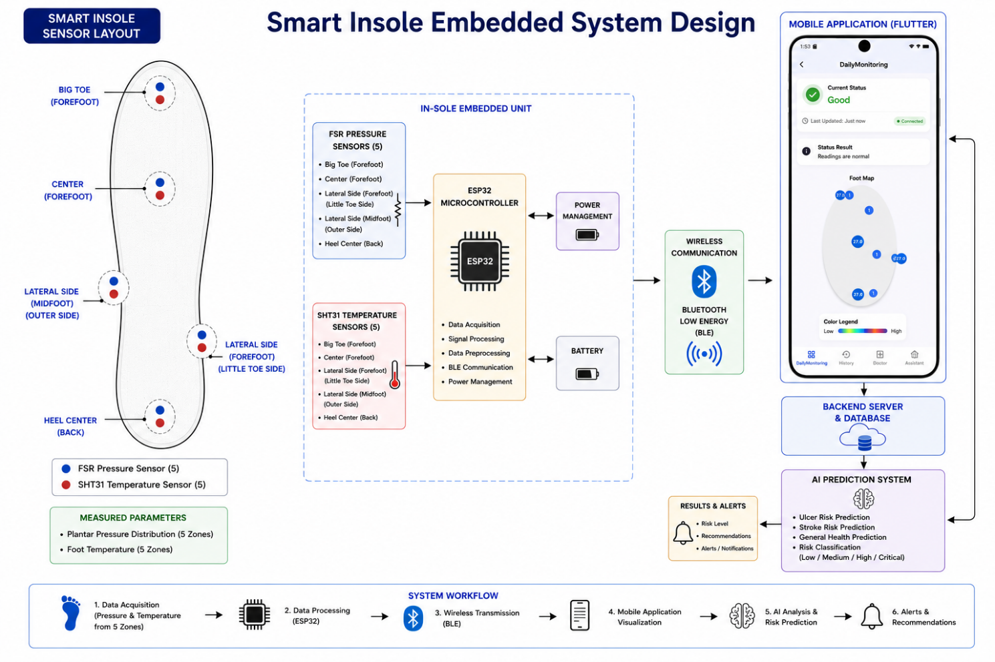
Figure 11Smart Insole Embedded System Architecture.

The collected sensor data is processed using the ESP32 microcontroller, which performs real-time data acquisition, initial data preprocessing operations, and wireless data transmission through Bluetooth Low Energy (BLE) communication.
The Smart Insole subsystem supports:
• Real-time pressure monitoring
• Foot temperature analysis
• Continuous healthcare sensing
• Wireless healthcare data transmission
• Early diabetic foot risk detection
• Smart wearable healthcare integration
The collected healthcare data is transmitted to the mobile healthcare application, where AI-based analysis and ulcer risk prediction are performed.

3.1.2 Mobile Application (Flutter)
The mobile healthcare application represents the primary user interaction interface within the proposed intelligent healthcare platform.
The application was developed using the Flutter framework to provide cross-platform compatibility, responsive user interfaces, and efficient healthcare data visualization.
The mobile application enables users to interact with different healthcare modules including smart insole monitoring, diabetic foot ulcer image classification, stroke prediction, and general disease prediction systems.
The application provides functionalities such as:
• Real-time smart healthcare monitoring
• Diabetic foot image upload and AI-based analysis
• AI prediction results visualization
• Healthcare recommendations and alert notifications
• User authentication and profile management
• Navigation between integrated healthcare modules
• Communication with backend services and AI models
The Flutter-based architecture improves portability and allows deployment on multiple mobile operating systems while maintaining consistent application performance and healthcare user experience.

3.1.3 Backend System
The backend subsystem represents the central processing and communication layer of the proposed healthcare platform. The backend was designed to manage healthcare data transmission, AI model communication, database operations, and secure communication between integrated system modules.
The backend services handle incoming healthcare data from the mobile application and embedded smart insole subsystem. The backend infrastructure performs preprocessing operations, API management, AI model communication, and healthcare result transmission.
The backend architecture supports:
• Secure healthcare data management
• AI model integration and prediction inference
• Real-time API communication
• Database storage and retrieval
• User authentication and session management
• Cloud-based healthcare services
The backend infrastructure improves system scalability and enables efficient communication between IoT devices, mobile applications, and AI healthcare services.
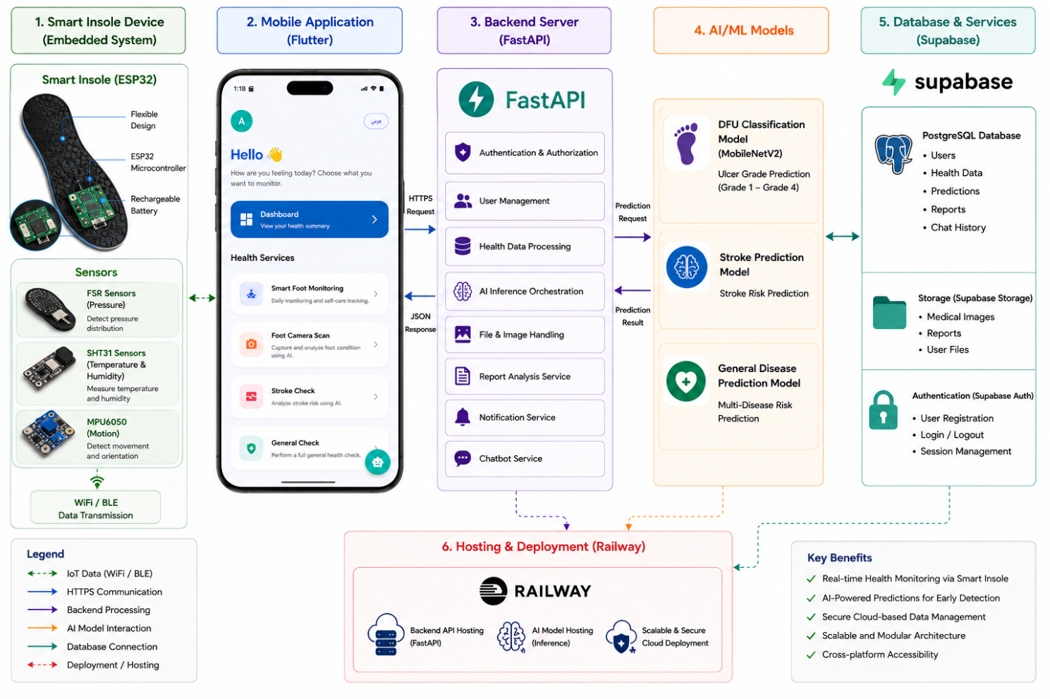
Figure 12Backend Infrastructure and AI Services Integration within the Proposed Intelligent Healthcare Platform.

3.1.4 AI Services Integration
Artificial intelligence technologies represent the core intelligent analysis layer within the proposed healthcare platform. Multiple machine learning and deep learning models were integrated to support healthcare prediction, medical image analysis, and AI-assisted healthcare decision support.

The AI subsystem integrates:
• Random Forest model for ulcer risk prediction
• MobileNetV2 model for diabetic foot ulcer image classification
• Stroke prediction machine learning model
• General disease prediction system
• AI-powered healthcare assistant
The integrated AI services analyze healthcare data collected from sensors, medical images, and patient healthcare parameters to generate AI prediction results and healthcare recommendations.
The AI integration layer enhances:
• Automated healthcare analysis
• Early disease prediction
• Intelligent medical assistance
• Real-time healthcare monitoring
• Preventive healthcare support
• Decision-making assistance
The integration of AI technologies significantly improves the intelligence and automation capabilities of the proposed healthcare system.

3.2 System Architecture
The proposed intelligent healthcare platform follows a multi-layered architecture that integrates embedded healthcare sensing devices, wireless communication technologies, backend services, AI prediction models, and mobile healthcare applications.
The architecture was designed to support scalability, modularity, real-time healthcare monitoring, and efficient communication between integrated system components.
The healthcare platform architecture enables seamless healthcare data collection, transmission, analysis, and visualization while supporting intelligent healthcare monitoring services and AI-assisted healthcare decision-making.

3.2.1 Flow Diagram
The system flow diagram illustrates the overall operational workflow of the proposed healthcare platform from healthcare data acquisition to prediction result generation and mobile healthcare application visualization.
The workflow begins with healthcare data acquistion through smart sensors and user healthcare inputs. The collected data is then transmitted to the backend system, where preprocessing and AI-based analysis are performed. Finally, the generated healthcare prediction results and recommendations are displayed to users through the mobile application.
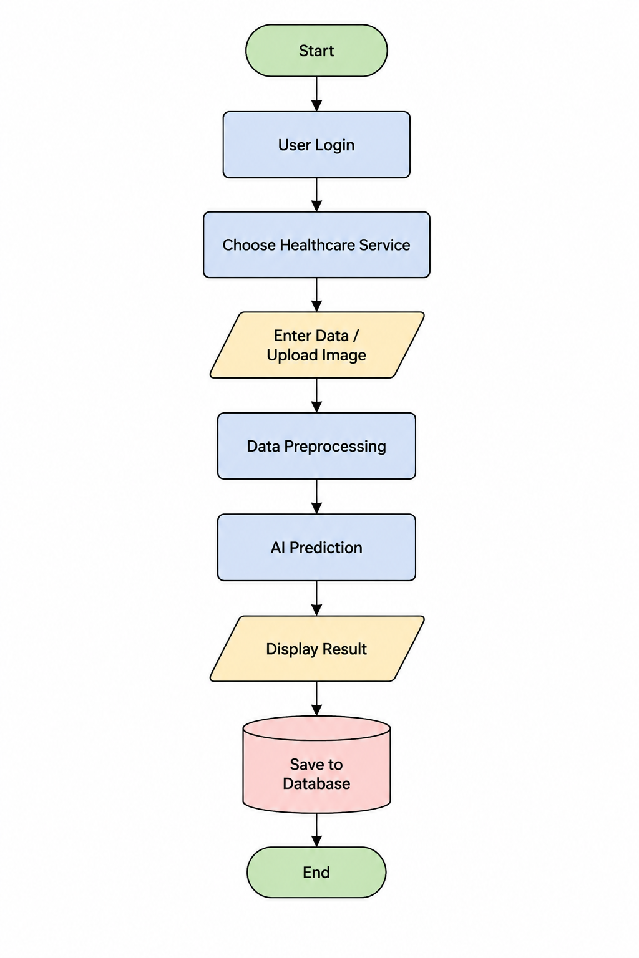
Figure 13System Flowchart of the Proposed Intelligent Healthcare System.

3.2.2 Data Flow Diagram (DFD)
The Data Flow Diagram (DFD) represents the flow of healthcare data between system entities, processing subsystems, databases, AI services, and mobile healthcare application interfaces.
The DFD illustrates how healthcare information is collected, processed, transmitted, stored, analyzed, and visualized throughout the healthcare platform.
The diagram improves understanding of system communication workflows and healthcare data interactions between different platform components.

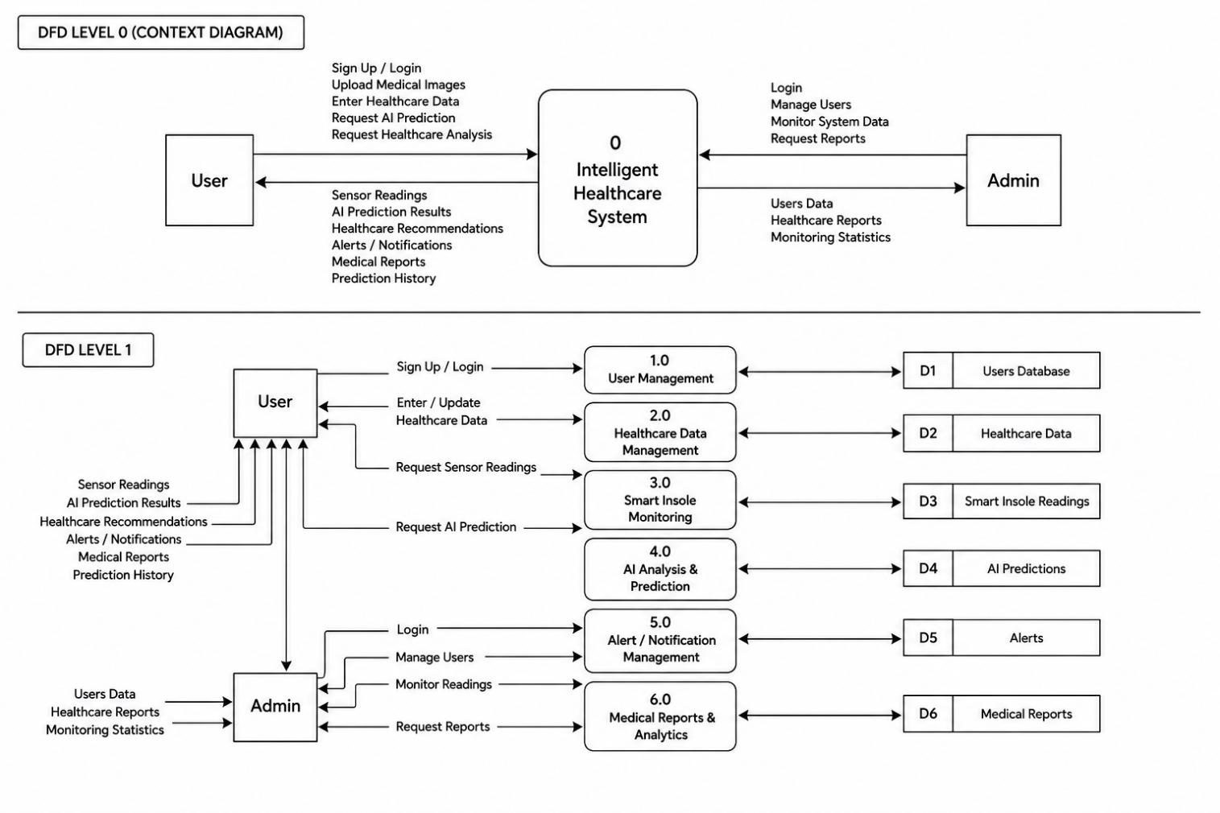
Figure 14Data Flow Diagram (DFD) of the Proposed Intelligent Healthcare System.

3.2.3 Use Case Diagram
The Use Case Diagram illustrates the interactions between users and the proposed intelligent healthcare platform. The diagram identifies the main system functionalities and demonstrates how users and administrators interact with different healthcare modules.
The use case model includes functionalities such as:
• User registration and login
• Smart insole monitoring
• Diabetic foot ulcer image analysis
• Stroke prediction
• General health assessment
• AI-powered healthcare assistance
• Viewing healthcare recommendations and alerts
The Use Case Diagram improves understanding of user-system interactions and provides a high-level functional overview of the operational capabilities of the proposed healthcare platform.
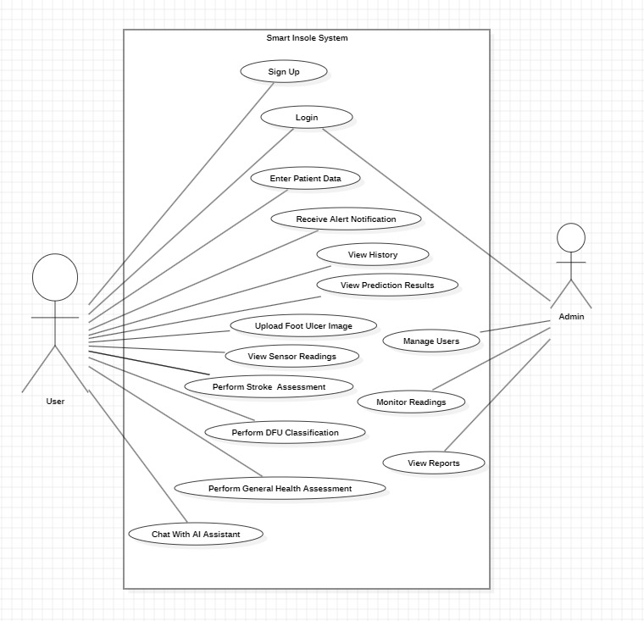
Figure 15Use Case Diagram of the Proposed Intelligent Healthcare System.

Chapter 4
Implementation

4. Implementation
This chapter presents the implementation details of the proposed intelligent healthcare system. The implementation phase focused on integrating AI prediction models, mobile healthcare technologies, backend services, cloud infrastructure, and embedded healthcare monitoring components into a unified healthcare platform.
The implementation process involved the development of multiple AI prediction systems, mobile healthcare interfaces, backend APIs, database services, and cloud-based healthcare communication mechanisms. The overall system was designed to support real-time healthcare monitoring, intelligent healthcare analysis, and AI-assisted healthcare decision-making support.
The implementation stage emphasized system scalability, computational efficiency, cross-platform mobile compatibility, secure healthcare data management, and real-time communication between system modules.

4.1 AI Model Implementation
Artificial intelligence models represent the core intellligent analytical components of the proposed healthcare platform. Multiple machine learning and deep learning models were implemented to support diabetic foot ulcer prediction, stroke risk analysis, general disease prediction, and AI-assisted healthcare decision support.
The AI subsystem was implemented using Python-based AI and machine learning frameworks and healthcare datasets obtained from publicly available medical data sources.
The implemented models were optimized to achieve high prediction accuracy while maintaining computational efficiency suitable for real-time mobile healthcare applications.
The AI implementation pipeline included:
• Healthcare dataset preparation
• Data preprocessing and normalization
• Feature engineering and extraction
• Model training and validation
• Hyperparameter optimization
• Performance evaluation
• Backend integration and deployment
The implemented AI models were integrated into the backend infrastructure to provide real-time AI healthcare prediction services through the mobile application.
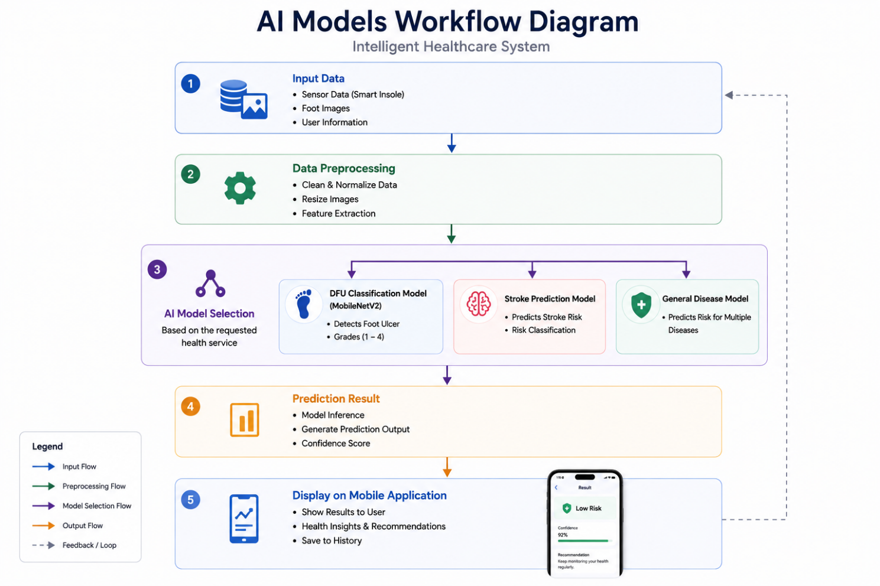
Figure 16AI Models Workflow and Prediction Pipeline of the Proposed Healthcare Platform.

4.1.1 DFU Image Classification Implementation
The diabetic foot ulcer prediction subsystem was implemented using both sensor-based healthcare prediction analysis and deep learning-based medical image classification techniques.
The image classification model was developed using the MobileNetV2 convolutional neural network architecture due to its lightweight design, high computational efficiency, and strong medical image classification accuracy.
The model was trained using diabetic foot ulcer image datasets containing multiple ulcer severity grades.
Image preprocessing operations including resizing, tensor representation conversion and normalization were applied before model training and inference.
The implementation process included:
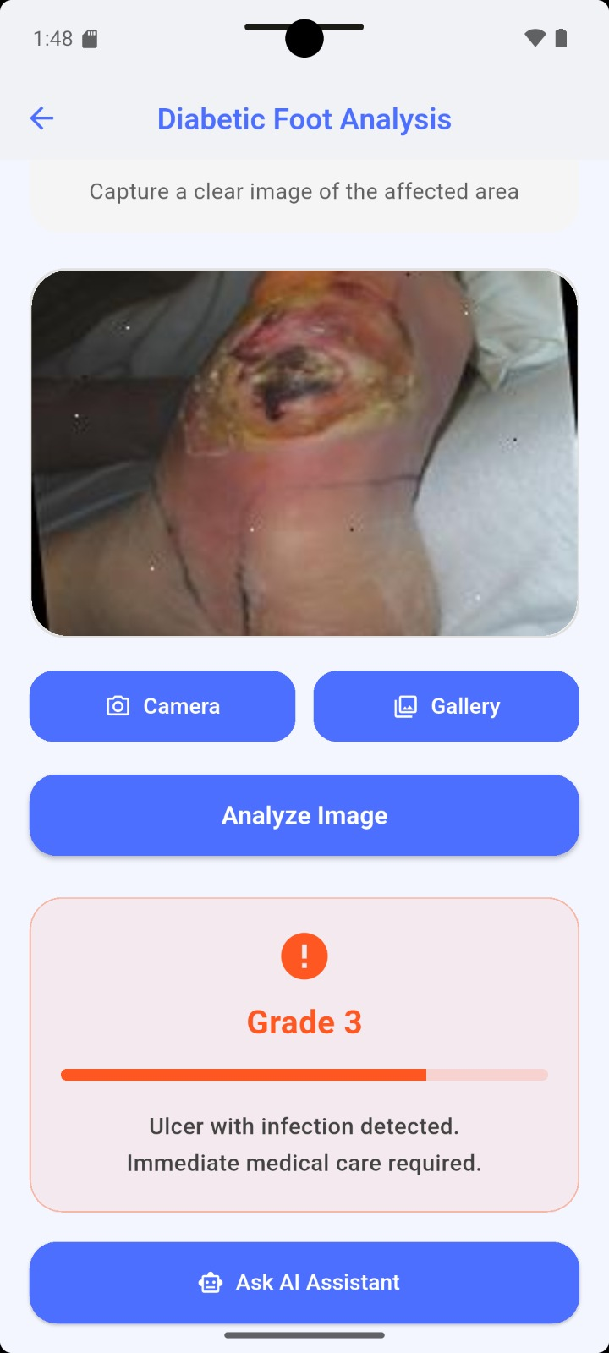
• Medical image preprocessing
• Dataset augmentation
• MobileNetV2 transfer learning
• Feature extraction
• Softmax-based classification
• Ulcer severity grading prediction
Figure 17Diabetic Foot Ulcer Image Classification and Severity Prediction Interface.
The final model classifies diabetic foot ulcer images into four severity grades ranging from Grade 1 to Grade 4.
The implemented model achieved strong classification performance during testing and validation stages, demonstrating strong predictive capability in recognizing ulcer severity patterns.

4.1.2 Stroke Prediction Model
The stroke prediction subsystem was implemented using a supervised machine learning model designed to estimate stroke risk probabilities based on patient healthcare parameters and lifestyle-related features.
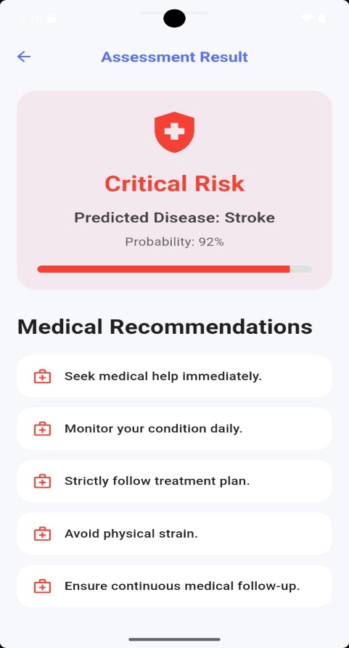
The implemented model analyzes multiple healthcare indicators including demographic information, physiological measurements, medical history, and lifestyle conditions associated with stroke risk.
The implementation process included:
• Healthcare data preprocessing
• Feature selection and normalization
• Training and testing dataset separation
• Machine learning model training
• Prediction probability estimation
• Risk classification and interpretation
Figure 18Stroke Risk Prediction Result Interface with Healthcare Recommendations.
The implemented model generates prediction probabilities and classifies users into different stroke risk categories ranging from low-risk conditions to critical stroke risk conditions.
The generated prediction results are integrated into the mobile application interface, where users receive healthcare recommendations, alert notifications and risk warnings.

4.1.3 General Disease Prediction Model
The general disease prediction subsystem was implemented to support intelligent healthcare analysis and multi-disease prediction using patient healthcare information and lifestyle-related parameters.
The system analyzes multiple healthcare indicators including glucose level, blood pressure, triglycerides, HbA1C, smoking behavior, stress level, sleep duration, physical activity, and family medical history.
The implementation workflow included:
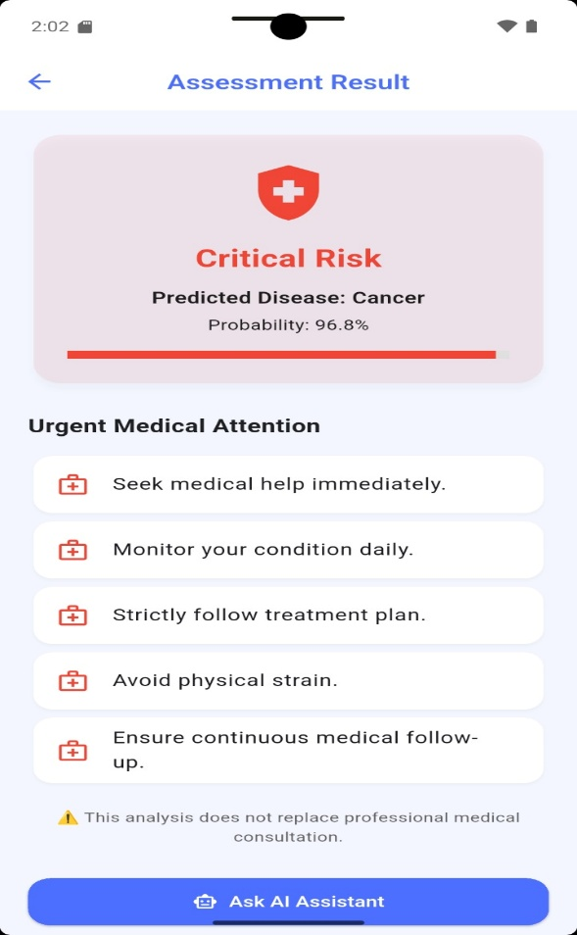
• Healthcare feature preprocessing
• Feature scaling and normalization
• Disease classification model training
• Prediction probability calculation
• Risk interpretation generation
• Recommendation system integration

Figure 19General Disease Prediction Result Interface with Healthcare Recommendations.

The implemented healthcare prediction model supports prediction of multiple health conditions including:
• Diabetes
• Hypertension
• Obesity
• Asthma
• Arthritis
• Cancer risk conditions
The prediction subsystem improves preventive healthcare capabilities by supporting early disease detection and healthcare awareness.

4.2 Mobile Application Implementation
The mobile healthcare application was implemented using the Flutter framework to provide cross-platform compatibility, responsive user interfaces, and efficient integration with AI-powered healthcare services.
The application was designed to provide users with real-time healthcare monitoring, AI-based healthcare analysis, healthcare visualization, and AI-assisted healthcare recommendations through an integrated healthcare platform.
The Flutter implementation emphasized:
• User-friendly healthcare application interfaces
• Cross-platform deployment
• Real-time healthcare visualization
• Backend API communication and integration
• Secure user authentication
• Efficient navigation between healthcare modules

4.2.1 Core Structure and Navigation
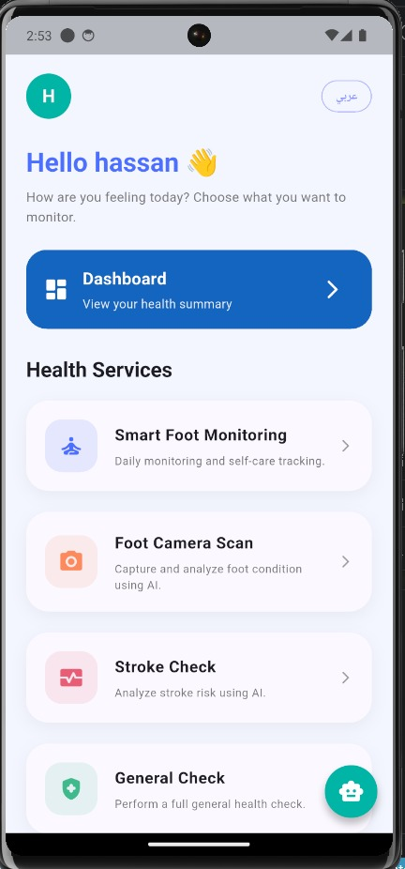
The mobile application architecture was designed using modular Flutter components to improve maintainability, scalability, and navigation flexibility and efficiency between healthcare modules.
The implemented navigation system allows users to efficiently access:
• Smart foot monitoring
• Diabetic foot ulcer analysis
• Stroke prediction
• General health assessment
• AI-powered healthcare assistant
• Healthcare history tracking and medical reports
The modular architecture improves application organization and enhances user interaction with healthcare services.
Figure 20Main Mobile Application Interface and Navigation Structure.

4.2.2 User Authentication
The authentication subsystem was implemented to provide secure user access and account management functionalities within the healthcare platform.
The authentication process supports:
• User registration
• Secure user login
• Session management
• User authentication and identity verification
• Protected healthcare data access
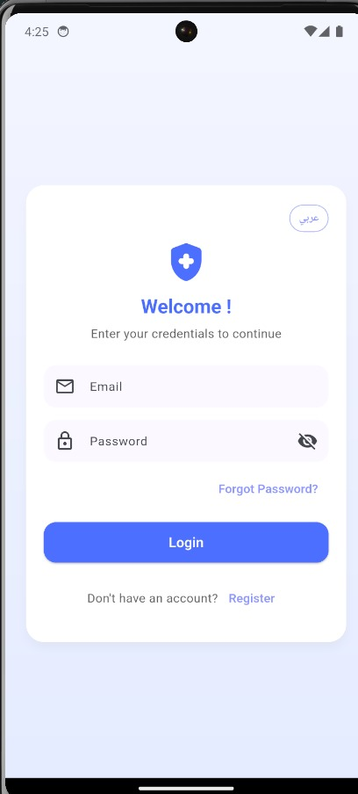
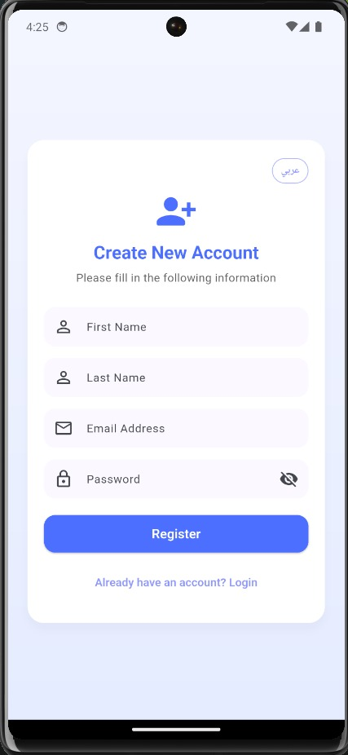
Figure 21. User Authentication Interfaces Including Login and Registration Screens.
The authentication system was integrated with backend and database services to ensure secure healthcare information management and personalized user interaction.

4.2.3 Health Dashboard
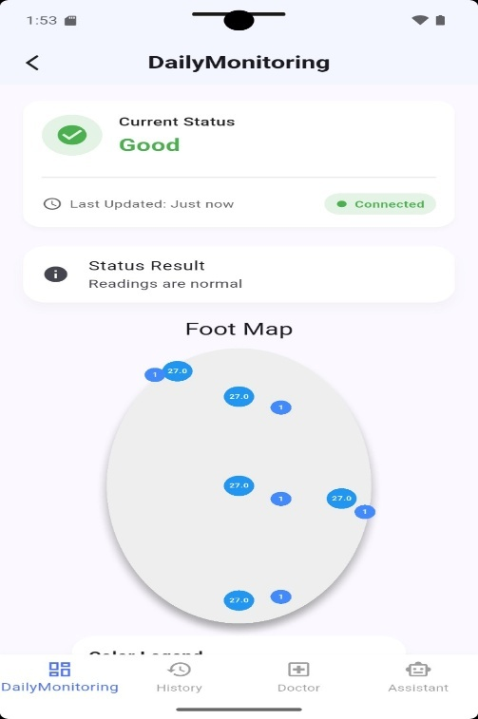
The health dashboard subsystem provides real-time visualization of healthcare readings, AI prediction results, and monitoring information collected from the smart insole subsystem.
The dashboard displays:
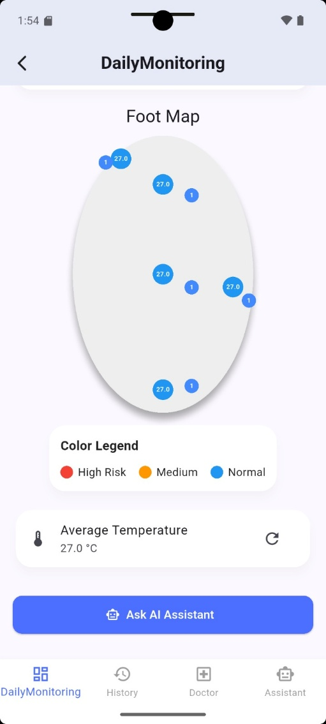
• Foot pressure distribution visualization
• Foot temperature monitoring
• Ulcer risk indication levels
• Sensor status visualization
• Healthcare alerts and recommendations
The dashboard implementation improves healthcare awareness and supports continuous healthcare monitoring and patient awareness.
Figure 22Smart Insole Health Dashboard for Real-Time Monitoring and Risk Visualization.

4.2.4 Nutrition Planner Module
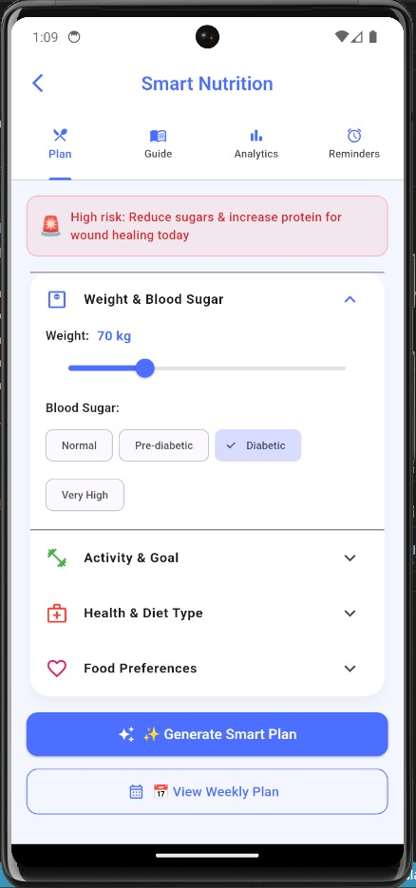
The nutrition planner module was implemented to support smart healthcare lifestyle management and dietary awareness for users with chronic health conditions.
The module assists users by providing:
• Personalized nutrition planning
• Healthy food recommendations
• Personalized dietary guidance
• Calorie and nutrition monitoring support
• Preventive healthcare and wellness awareness
Figure 23. Smart Nutrition Planning and Dietary Recommendation Interface.
The nutrition subsystem improves healthcare management by encouraging healthy lifestyle behaviors and healthy nutritional balance.

4.2.5 Chatbot Integration
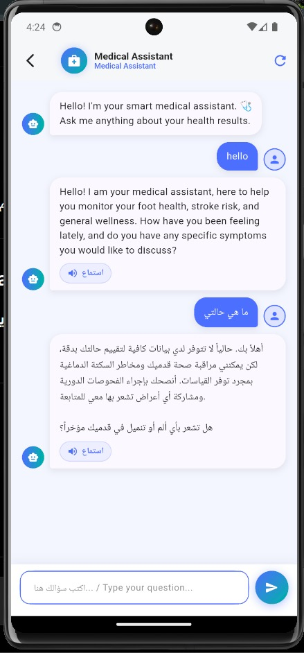
The healthcare chatbot subsystem was integrated to provide AI-powered healthcare assistance and automated interaction between users and the intelligent healthcare platform.
The chatbot supports:
• Healthcare-related question answering
• Basic healthcare and medical guidance
• Navigation assistance
• Healthcare recommendation support
• AI-assisted communication
Figure 24AI-Powered Healthcare Chatbot Integrated within the Mobile Application.
The chatbot improves user interaction and enhances accessibility to intelligent healthcare support services.

4.2.6 Medical Report Upload & Analysis
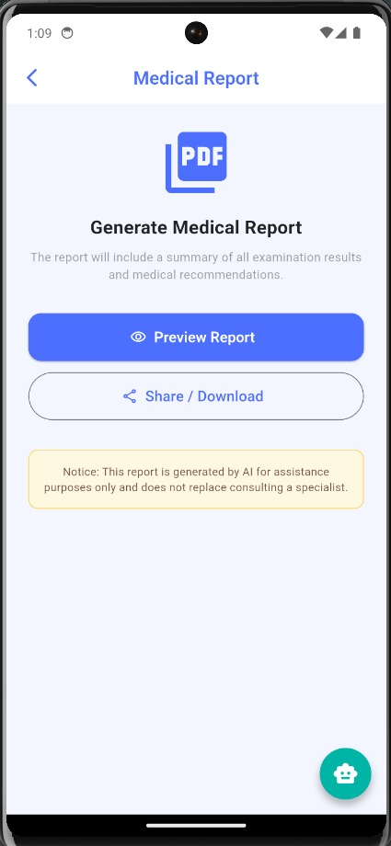
The medical report analysis subsystem was implemented to allow users to upload healthcare reports and receive AI-assisted medical report interpretation support.
The subsystem supports:
• Medical report upload
• Medical report file processing and validation
• AI-assisted report interpretation
• Healthcare recommendation and insight generation
• Medical information summarization
Figure 25. Medical Report Generation and AI-Assisted Analysis Interface
The integration of intelligent report analysis improves healthcare accessibility and enhances medical information understanding for users.

4.2.7 Future Scenario Simulation
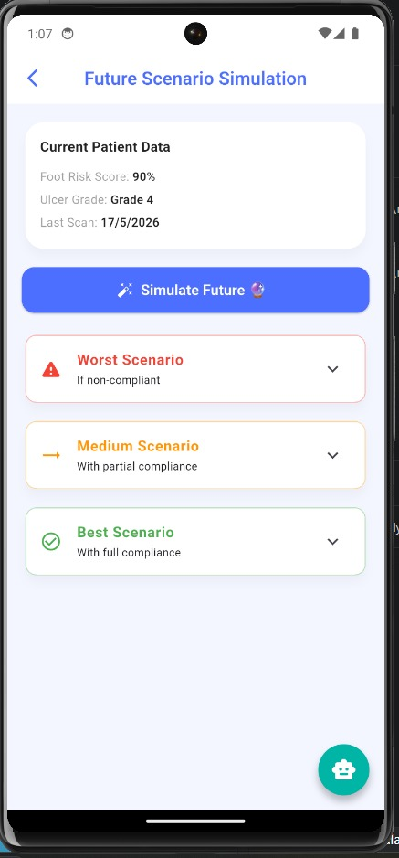
The Future Health Prediction module was implemented as a simulation-based healthcare prediction and forecasting subsystem designed to provide predictive insights based on historical patient data, sensor readings, healthcare assessments, and AI-generated healthcare indicators.
The subsystem analyzes previously collected healthcare information including smart insole readings, diabetic foot ulcer assessments, stroke risk evaluations, and general health prediction results to simulate potential future healthcare risks and disease progression trends.
The predictive simulation mechanism assists users by providing:
Figure 26Future Health Scenario Simulation and Predictive Healthcare Monitoring Interface.
• Future health risk estimation
• Trend-based healthcare condition monitoring
• Early warning indications
• Continuous patient healthcare evaluation
• Preventive healthcare recommendations

The simulation-based approach improves proactive healthcare awareness and preventive monitoring by helping users monitor possible changes in their health conditions over time and encouraging early medical consultation when abnormal healthcare trends are detected.

4.2.8 AI Result Explanation System
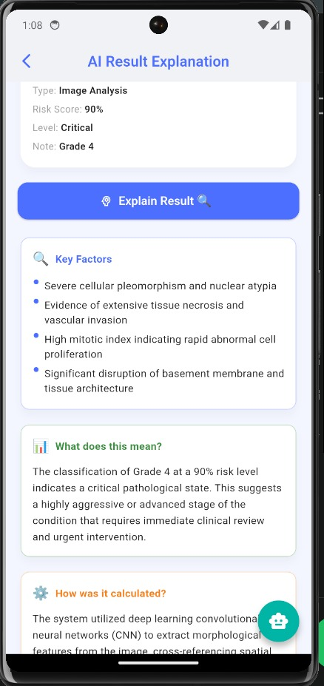
The AI Result Explanation subsystem was implemented to improve the interpretability, transparency and usability of AI-generated healthcare predictions within the mobile healthcare application.
Figure 27. AI-Based Healthcare Result Explanation and Interpretation Interface.
The subsystem provides detailed explanations for prediction results generated by the diabetic foot ulcer classification model and other healthcare prediction modules. Instead of displaying only the final prediction output, the system presents additional analytical insights to help users better understand the detected medical condition and associated healthcare risks.

The explanation interface displays:
• Prediction type and risk level
• Prediction confidence score
• Severity classification result
• Key healthcare indicators and contributing factors
• Healthcare interpretation of the prediction result
• AI-generated healthcare explanation and recommendations
The subsystem enhances transparency and improves user understanding of AI-based healthcare decision-making processes by providing simplified and understandable healthcare explanations in an interactive and user-friendly format.
The AI explanation mechanism supports healthcare awareness and encourages users to seek appropriate medical consultation when critical healthcare conditions are detected.

4.3 Backend and Cloud Integration
The backend subsystem was implemented to manage healthcare data transmission and communication, AI model integration, cloud-based healthcare services, and secure communication and interaction between system modules.
The backend infrastructure was designed to support scalability, real-time communication, secure healthcare data management, and efficient real-time AI inference services.

4.3.1 Backend Architecture
The backend architecture was implemented using RESTful API-based communication mechanisms to connect the mobile application, AI prediction models, embedded healthcare devices, and cloud database services.
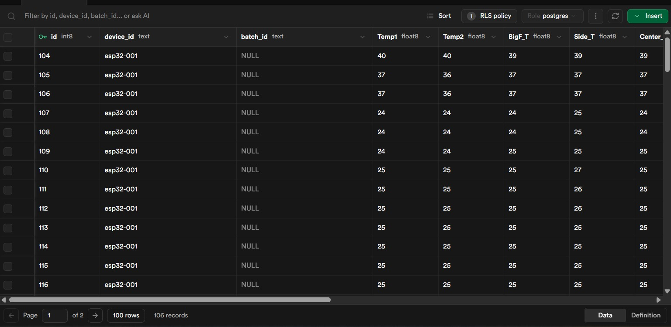
Figure 28Supabase Database Interface for Real-Time Smart Insole Sensor Data Storage and Management.
The backend subsystem supports:
• Healthcare data processing
• Real-time AI inference services
• User authentication
• Database communication
• Real-time API interaction
• Cloud-based healthcare integration
The architecture improves system scalability and enables efficient real-time communication between all healthcare platform components.

4.3.2 Database Design
The healthcare database was implemented to support secure storage, retrieval and management of healthcare information, AI prediction results, sensor readings, and user healthcare and medical records.
The database structure supports:
• User account management
• Real-time sensor reading storage
• AI prediction history
• Healthcare assessment records
• Medical image and report management
• Alert and notification records
The database design improves healthcare data organization and supports scalable and efficient healthcare information management

4.3.3 API Communication
API communication mechanisms were implemented to enable secure and efficient real-time interaction between the mobile healthcare application, backend services, AI models, and database infrastructure.
The implemented APIs support:
• User authentication requests
• Healthcare data transmission and processing
• AI prediction requests
• Real-time sensor reading communication
• Healthcare result retrieval
• Cloud synchronization services
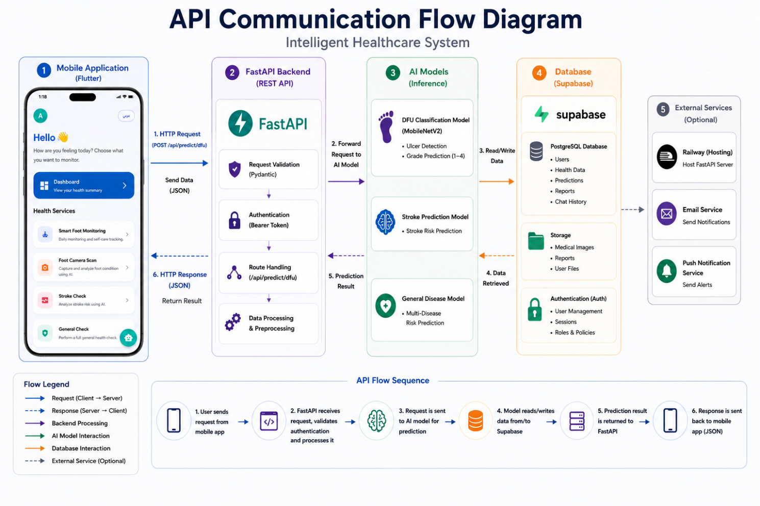
The API integration enables real-time healthcare communication and improves interoperability and real-time communication between system components.
Figure 29API Communication Flow Between the Mobile Application, Backend Services, AI Models, and Cloud Database Infrastructure.

Chapter 5
Testing and Evaluation

5. Testing and Evaluation
This chapter presents the testing procedures, experimental evaluation methodologies, and performance analysis conducted to validate the functionality, reliability and effectiveness of the proposed intelligent healthcare system. Multiple testing scenarios were performed to evaluate the smart insole subsystem, diabetic foot ulcer classification model, stroke prediction model, and general disease prediction subsystem. The chapter also discusses system performance metrics, system response time evaluation, and practical limitations and challenges encountered during system development and testing.

5.1 Testing Scenarios
Several testing scenarios were implemented to evaluate the system operational reliability, AI prediction performance, and real-time healthcare monitoring capabilities of the proposed intelligent healthcare system. The testing phase focused on validating real-time sensor monitoring, diabetic foot ulcer image classification, healthcare prediction accuracy, and system response performance and behavior.

5.1.1 Smart Insole Data Testing
The Smart Insole subsystem was tested to evaluate the reliability of pressure and temperature data acquisition from the embedded pressure and temperature sensors.
The testing process verified the accuracy of sensor readings, wireless data transmission, and real-time monitoring functionality within the Flutter-based mobile healthcare application.
The testing procedures included:
• Pressure sensor reading validation
• Temperature sensor monitoring evaluation
• BLE communication testing
• Real-time healthcare data visualization testing
• Sensor synchronization testing
• Continuous monitoring stability evaluation
The collected sensor readings were successfully transmitted from the ESP32 microcontroller to the mobile healthcare application through Bluetooth Low Energy (BLE) communication.
The monitoring subsystem demonstrated stable real-time healthcare data visualization and continuous sensor updates.

5.1.2 Diabetic Foot Ulcer Classification Testing
The diabetic foot ulcer classification subsystem was tested to evaluate the performance and reliability of the deep learning model in classifying ulcer severity levels from uploaded medical images.
Multiple testing scenarios were conducted using diabetic foot ulcer image samples representing different ulcer severity grades. The testing process verified the ability of the implemented MobileNetV2 model to analyze medical images, extract important visual features, and generate accurate ulcer severity predictions.
The testing procedures included:
• Medical image preprocessing validation
• Ulcer image classification testing
• Severity grading evaluation
• Prediction probability verification
• AI result interpretation testing
• Input-output consistency evaluation
The implemented classification subsystem successfully analyzed diabetic foot ulcer images and generated severity classification results ranging from Grade 1 to Grade 4.
The generated outputs included prediction confidence scores, ulcer severity levels, healthcare risk indications, and AI-assisted healthcare recommendations.

The testing results demonstrated stable classification performance and strong predictive capability in recognizing diabetic foot ulcer severity patterns under different testing scenarios.

5.1.3 Stroke Prediction Testing
The stroke prediction subsystem was tested using healthcare parameters associated with stroke risk assessment.
Multiple test scenarios were performed to validate the prediction model’s ability to predict stroke risk levels and generate healthcare recommendations.
The testing procedures included:
• Healthcare parameter validation
• Stroke risk prediction testing
• Risk classification evaluation
• AI recommendation generation
• Prediction input-response consistency testing
The prediction subsystem successfully generated healthcare risk assessments based on user healthcare information.
The generated results included prediction probability scores, risk indication levels, and preventive healthcare recommendations.

5.1.4 General Health Prediction Testing
The general health prediction subsystem was tested using multiple healthcare parameters collected from users through the mobile healthcare application interface.
The testing process evaluated the ability of the AI model to predict potential disease conditions and generate healthcare recommendations.
The testing procedures included:
• Healthcare data collection testing
• Multi-disease prediction evaluation
• Risk classification testing
• Recommendation generation validation
• User input consistency testing
The subsystem successfully generated predictive healthcare assessments for multiple disease categories including diabetes, hypertension, obesity, arthritis, asthma, and cancer-related healthcare risk estimation scenarios.

5.2 Performance Metrics
The system performance evaluation phase focused on analyzing the predictive accuracy, computational efficiency, and system response performance of the proposed intelligent healthcare system.
Multiple performance evaluation metrics were utilized to assess AI model performance, prediction reliability, and system responsiveness.

5.2.1 Accuracy and Model Evaluation
The AI models were evaluated using standard AI and machine learning performance metrics including accuracy, precision, recall, and F1-score. These metrics were utilized to analyze the predictive performance effectiveness and classification reliability of the implemented healthcare models.
The diabetic foot ulcer classification model achieved high classification performance across multiple ulcer severity grades.
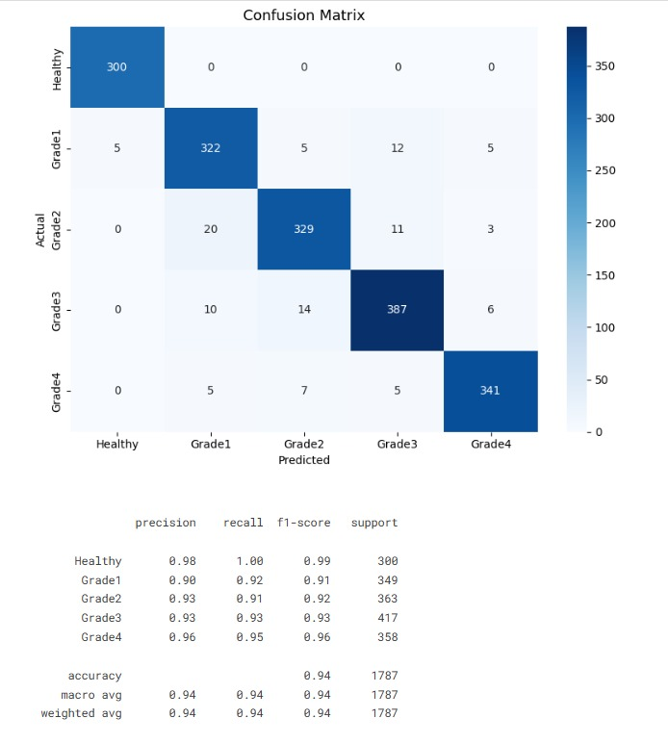
Figure 30Confusion Matrix and Classification Report of the DFU Image Classification Model.
Similarly, the stroke prediction and general disease prediction subsystems demonstrated reliable healthcare risk prediction capabilities.
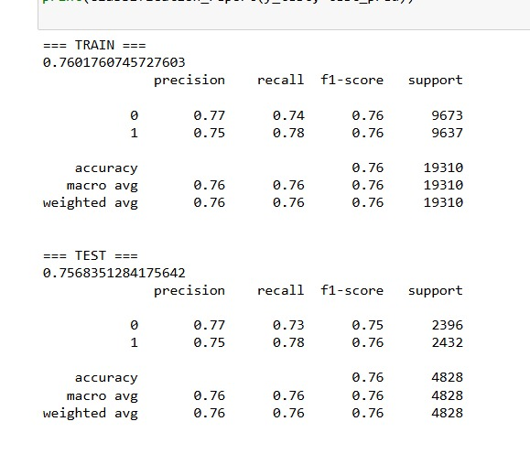
Figure 31Performance Evaluation Metrics for the Stroke Prediction Model

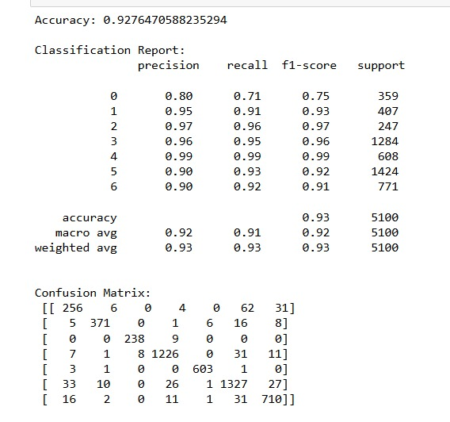
Figure 32. Performance Evaluation Metrics for the General Health Prediction Model.

The evaluation results indicate that the implemented AI models are capable of supporting intelligent healthcare monitoring and predictive healthcare analysis with satisfactory predictive performance levels.

5.2.2 System Response Time
System response time testing was conducted to evaluate the operational efficiency, latency, and responsiveness of the proposed healthcare platform.
The testing process evaluated the approximate processing time required for data transmission, AI inference generation, and healthcare result visualization.
The evaluated operations included:
• Sensor data transmission time
• Medical image analysis processing duration
• AI prediction response time
• Backend communication latency
• Mobile application response and update speed
The testing results demonstrated that the system was capable of generating healthcare predictions and updating monitoring information within acceptable real-time operational response durations suitable for practical real-time healthcare monitoring applications.

5.3 Discussion
This section discusses the experimental and testing results, system limitations, and technical and development insights gained during the implementation and evaluation phases of the intelligent healthcare system.

5.3.1 Results Analysis
The testing and evaluation results demonstrated the effectiveness of integrating artificial intelligence, IoT healthcare monitoring, and mobile healthcare technologies within a unified intelligent healthcare platform.
The Smart Insole subsystem successfully provided continuous monitoring of plantar pressure and foot temperature readings.
The AI classification and prediction subsystems demonstrated strong predictive performance in diabetic foot ulcer analysis, stroke risk estimation, and general disease prediction tasks.
The integration between the embedded healthcare device, mobile application, backend services, and AI models enabled real-time healthcare monitoring and automated AI-assisted healthcare analysis capabilities.
The obtained results indicate that the proposed system can support preventive healthcare monitoring and improve early healthcare risk awareness and preventive healthcare support.

5.3.2 Limitations
Despite the successful implementation and evaluation results, several limitations were identified during the development and testing phases.
The main limitations include:
• Limited healthcare dataset availability
• Dependence on sensor accuracy and stability
• Simulation-based future healthcare forecasting
• Limited clinical validation scenarios
• Variations in medical image quality
• Hardware and computational resource limitations in embedded systems
Additionally, the system currently operates as a research-oriented intelligent healthcare prototype system and has not yet undergone full-scale clinical validation and medical certification procedures.

5.3.3 Lessons Learned
The development process provided valuable technical, research, and implementation experience in multiple domains including artificial intelligence, embedded systems, Flutter-based mobile healthcare applications, backend integration, and healthcare data analysis.
Several important lessons were learned during the implementation process, including:
• Challenges of integrating AI with embedded healthcare systems
• Importance of healthcare data preprocessing and normalization
• Real-time communication synchronization between system components
• Mobile-to-backend API integration techniques
• AI deployment and healthcare system optimization strategies

The project also improved practical and technical understanding of intelligent healthcare system development and demonstrated the importance of interdisciplinary integration between modern healthcare technologies and artificial intelligence systems.

Chapter 6
Conclusion and Future Work

6. Conclusion and Future Work
This chapter summarizes the overall achievements and outcomes of the proposed intelligent healthcare system and discusses possible future enhancements that may improve system performance, scalability, healthcare intelligence, and real-world healthcare applicability.
The proposed system successfully integrated artificial intelligence, embedded healthcare monitoring, mobile healthcare technologies, and cloud-based services into a unified intelligent healthcare platform capable of supporting preventive healthcare monitoring and AI-assisted medical analysis.

6.1 Conclusion
The primary objective of this project was to design and implement an intelligent healthcare system capable of supporting early healthcare risk detection, continuous patient monitoring, and AI-assisted medical analysis using modern healthcare technologies.
The developed system successfully combined multiple technological domains including:
• Artificial intelligence
• Embedded systems
• Internet of Things (IoT)
• Mobile healthcare applications
• Cloud computing
• Medical image analysis
The implemented healthcare platform integrated a smart insole subsystem capable of monitoring plantar pressure distribution and foot temperature readings using embedded healthcare sensors connected through an ESP32 microcontroller.
The healthcare monitoring subsystem enabled continuous acquisition of physiological measurements and supported real-time healthcare visualization through the mobile healthcare application.
The diabetic foot ulcer image classification subsystem successfully utilized the MobileNetV2 deep learning architecture to classify ulcer severity levels based on medical image analysis. The implemented model demonstrated strong predictive performance and effective ulcer severity classification capabilities.
In addition, the project successfully implemented:
• Stroke risk prediction
• General disease prediction
• Healthcare recommendation generation
• AI-assisted healthcare interpretation
• Medical report analysis
• Future health prediction simulation
The Flutter-based mobile healthcare application provided an integrated healthcare environment that enabled users to interact with all healthcare services through a unified and user-friendly interface.

The backend infrastructure implemented using FastAPI frameworks, Supabase, and cloud deployment services enabled efficient communication between the embedded device, mobile application, AI models, and healthcare database services.
The testing and evaluation results demonstrated that the proposed healthcare system was capable of:
• Real-time healthcare monitoring
• AI-assisted healthcare analysis
• Predictive healthcare risk estimation
• Medical image classification
• Continuous healthcare data visualization
• Intelligent healthcare recommendation generation
The overall implementation demonstrated the technical feasibility of integrating artificial intelligence and IoT technologies within intelligent healthcare systems to support preventive healthcare monitoring and early healthcare intervention.
The project also provided valuable practical experience in AI integration, healthcare data processing, embedded system communication, backend development, mobile healthcare implementation, and interdisciplinary healthcare technology design.

6.2 Future Enhancements
Although the proposed healthcare system achieved successful implementation and promising testing results, several future enhancements may further improve system capabilities, scalability, intelligence, and real-world healthcare deployment and applicability.
Future development directions may focus on improving AI prediction performance, expanding healthcare functionalities, integrating additional wearable healthcare technologies, and enhancing healthcare data analysis capabilities.

6.2.1 AI Model Improvement
Future improvements may include the utilization of larger medical datasets and more advanced AI and deep learning architectures to improve prediction accuracy and healthcare analysis performance.
Potential enhancements include:
• Increasing healthcare dataset diversity
• Improving medical image quality and augmentation techniques
• Implementing advanced deep learning architectures
• Enhancing model generalization capabilities
• Reducing AI prediction latency and computational overhead
• Supporting continuous AI model retraining
Future work may also involve integrating explainable AI (XAI) techniques to improve transparency and interpretability of healthcare prediction results.
Additionally, future clinical validation using real-world medical environments may improve system reliability and healthcare applicability.

6.2.2 Smart Healthcare Expansion
The proposed healthcare platform may be expanded in the future to support additional healthcare monitoring services and intelligent healthcare functionalities.
Possible future expansions include:
• Heart rate monitoring
• Blood glucose integration
• Blood oxygen monitoring
• ECG signal analysis
• Sleep monitoring
• Mental health assessment
• Personalized healthcare analytics
Future versions of the system may also support remote doctor-patient communication and real-time telemedicine services.
The integration of advanced healthcare analytics may further improve preventive healthcare monitoring and personalized healthcare support.

6.2.3 Integration with Wearable Devices
Future development may focus on integrating the healthcare platform with additional wearable healthcare technologies and smart medical devices.
Potential integrations include:
• Smartwatches
• Smart fitness tracking devices
• Continuous glucose monitoring systems
• Wearable ECG sensors
• Smart healthcare bracelets
• Wireless smart medical monitoring devices
The integration of wearable healthcare technologies may improve healthcare data collection, increase monitoring accuracy, and enhance continuous healthcare observation capabilities.
Future IoT integration may also enable large-scale healthcare monitoring ecosystems connected through cloud-based healthcare infrastructures and AI-driven healthcare analytics.
The proposed intelligent healthcare system demonstrates strong potential for future expansion toward comprehensive AI-powered smart healthcare environments capable of supporting preventive healthcare, intelligent medical assistance and AI-powered healthcare monitoring.

References
[1] A. Howard, M. Zhu, B. Chen, D. Kalenichenko, W. Wang, T. Weyand, M. Andreetto, and H. Adam, “MobileNets: Efficient Convolutional Neural Networks for Mobile Vision Applications,” arXiv preprint arXiv:1704.04861, 2017.

[2] M. Sandler, A. Howard, M. Zhu, A. Zhmoginov, and L. Chen, “MobileNetV2: Inverted Residuals and Linear Bottlenecks,” Proceedings of the IEEE Conference on Computer Vision and Pattern Recognition (CVPR), pp. 4510–4520, 2018.

[3] L. Breiman, “Random Forests,” Machine Learning, vol. 45, no. 1, pp. 5–32, 2001.

[4] TensorFlow, “TensorFlow Official Documentation,” Available:
(https://www.tensorflow.org/api_docs)

[5] Flutter, “Flutter Official Documentation,” Available:
(https://docs.flutter.dev/)

[6] FastAPI, “FastAPI Official Documentation,” Available:
(https://fastapi.tiangolo.com/)

[7] Supabase, “Supabase Official Documentation,” Available:
(https://supabase.com/docs)

[8] Espressif Systems, “ESP32 Series Datasheet and Technical Documentation,” Available:
(https://documentation.espressif.com/esp32_datasheet_en.pdf?hl=ar-EG)

[9] Sensirion, “SHT31 Temperature and Humidity Sensor Datasheet,” Available:
(https://sensirion.com/media/documents/213E6A3B/63A5A569/Datasheet_SHT3x_DIS.pdf)

[10] Kaggle, “Diabetic Foot Pressure and Temperature Dataset,” Available:
(https://www.kaggle.com/datasets/ankitakash/diabetic-foot-pressure-analysis)

[11] Kaggle, “Stroke Prediction Dataset,” Available:
(https://www.kaggle.com/datasets/usman7788/stroke-prediction-dataset)

[12] Kaggle, “General Healthcare and Disease Prediction Dataset,” Available:
(https://www.kaggle.com/datasets/abdallaahmed77/healthcare-risk-factors-dataset)

[13] Kaggle, “Diabetic Foot Ulcer (DFU) Dataset,” Available:
(https://www.kaggle.com/datasets/laithjj/diabetic-foot-ulcer-dfu)
[14] S. Kumar, A. Sharma, and R. Gupta, “Deep Learning-Based Diabetic Foot Ulcer Classification Using MobileNet Architecture,” International Journal of Advanced Computer Science and Applications, vol. 13, no. 4, pp. 120–128, 2022.

[15] S. M. R. Islam, D. Kwak, M. H. Kabir, M. Hossain, and K.-S. Kwak, “The Internet of Things for Health Care: A Comprehensive Survey,” IEEE Access, vol. 3, pp. 678–708, 2015.

[16] World Health Organization (WHO), “Diabetes,” Available:
(https://www.who.int/health-topics/diabetes#tab=tab_1)

[17] American Diabetes Association, “Standards of Medical Care in Diabetes,” Available:
(https://diabetesjournals.org/clinical/article/40/1/10/139035/Standards-of-Medical-Care-in-Diabetes-2022)

[18] Python Software Foundation, “Python Official Documentation,” Available:
(https://docs.python.org/3/)

[19] OpenCV, “OpenCV Official Documentation,” Available:
(https://docs.opencv.org/3.4/pages.html)

[20] Bluetooth SIG, “Bluetooth Low Energy (BLE) Technology Overview,” Available:
(https://www.bluetooth.com/learn-about-bluetooth/tech-overview/)

[21] L. Aversano et al., “A Systematic Review on Artificial Intelligence Approaches for Smart Healthcare Systems,” National Institutes of Health (NIH), 2024. Available:
(https://pmc.ncbi.nlm.nih.gov/articles/PMC11623213/)

[22] Prof. Dr. [Muhamed Youssef], “Project Guidance Materials for Intelligent Healthcare System Development,” Available:
(https://drive.google.com/file/d/1KCkt4Ti_o-SGZ7TUV4nL-pRmO37d5TLn/view?usp=drive_link)

Appendices

Appendix A

-AI Model Code

A.1 MobileNetV2 Initialization
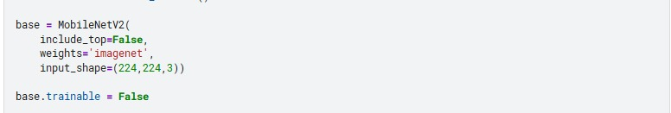

A.2 Classification Layers
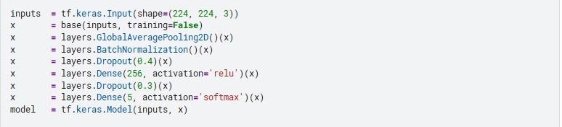
A.3 Random Forest Pipeline
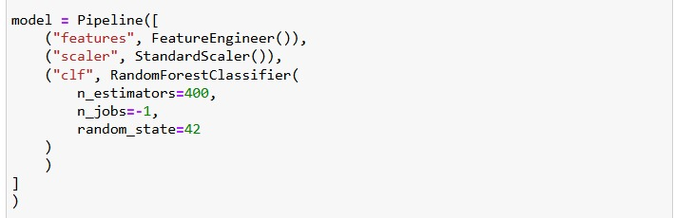

A.4 Prediction Generation
A.5 AI Model Evaluation Metrics


Appendix B

-Embedded Sensor Code

B.1 FSR Pressure Sensor Reading
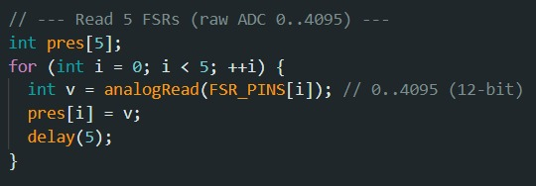
B.2 SHT31 Temperature Sensor Reading
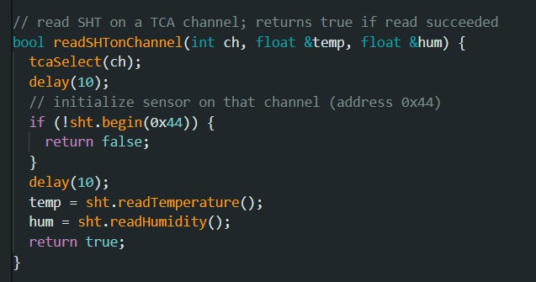
B.3 WiFi Connection
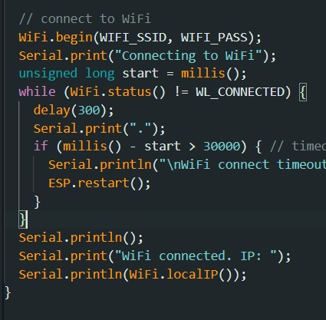

B.4 JSON Sensor Data Formatting and Transmission
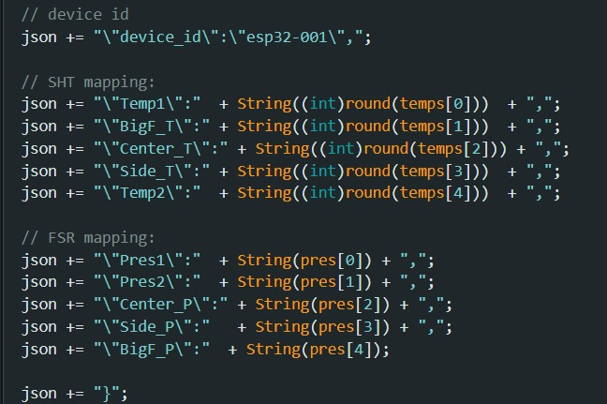

Appendix C

-Flutter Application Code
C.1 Navigation Between Screens
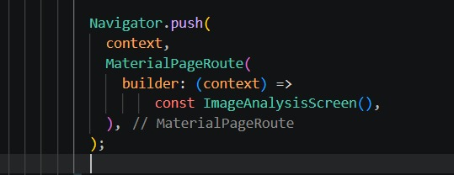

C.2 Medical Image Upload
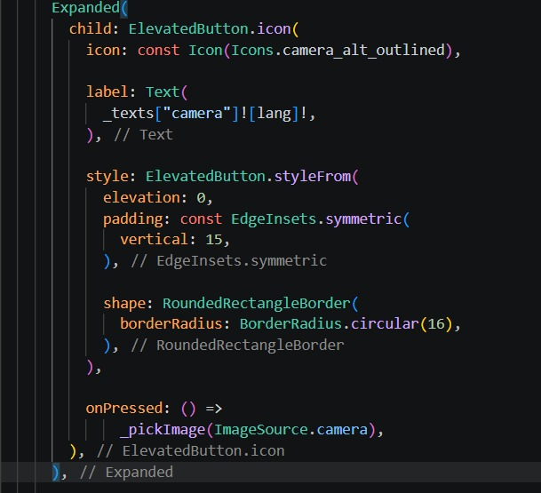
C.3 Connections
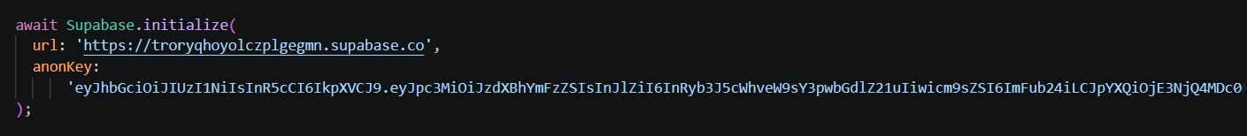

Appendix D

- Backend APIs
D.1 Supabase Database Table Structure
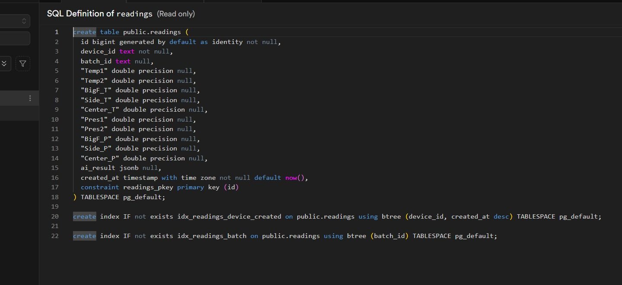
D.2 FastAPI Endpoint Documentation
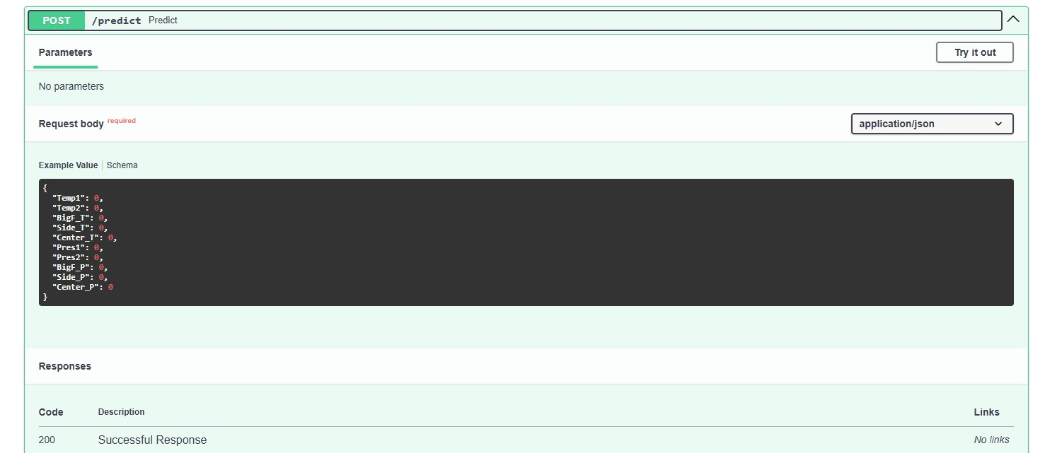

D.3 Backend Server Deployment and Runtime Monitoring

